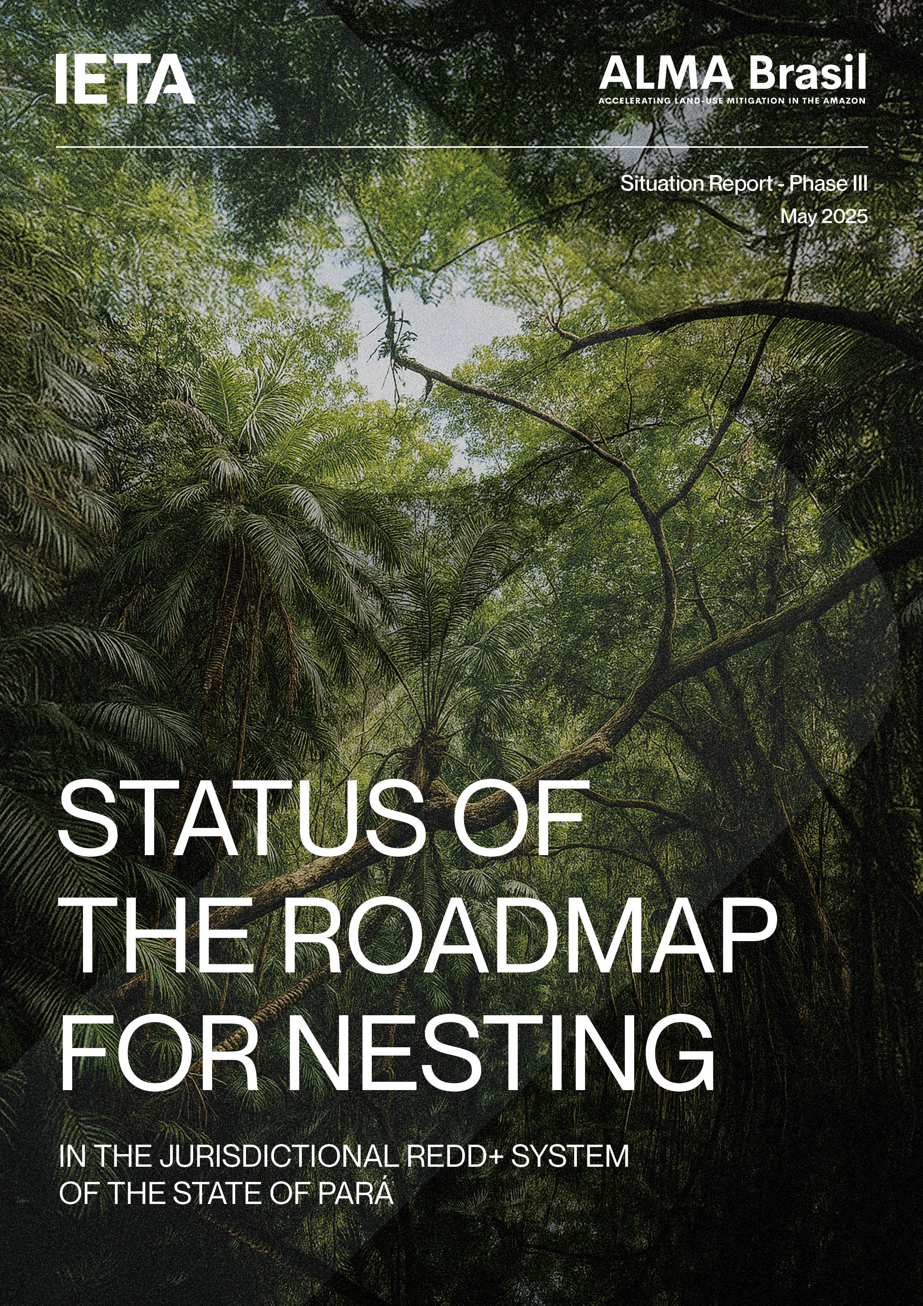

**Executive Summary**

**This report aims to compile the discussions and progress achieved during Phase III of the ALMA Brasil project. In a collaborative framework involving the Pará State Secretariat for the Environment and Sustainability (SEMAS), Amazon Environmental Research Institute (IPAM), The Nature Conservancy (TNC), and Pará Land Institute (ITERPA), the project explored the challenges of nesting carbon projects under the future Jurisdictional REDD+ Program in Pará. Particular focus was given to issues related to accounting, MRV (measurement, reporting, and verification), and safeguards, especially in terms of potential impacts on existing projects.**

Research, technical meetings, and stakeholder engagement activities provided inputs for the discussion of possible technical criteria to inform the state’s future nesting strategy. To support the development of a robust and efficient system, selected existing projects—nominated by developers interested in contributing to the initiative—were used as case studies to better understand real-world applications and analyse the tangible impacts that different nesting approaches could have on ongoing projects.

Regarding accounting and MRV, the fact that the State’s Jurisdictional Program and individual projects currently follow different standards and methodologies results in diverging reference periods, deforestation drivers, baseline data, and estimation methods, making alignment challenging. Given the preference for a decentralized nesting strategy, where nested projects would continue to issue credits independently but in alignment with the state’s program, assessing the accounting impact of nesting requires the development of a risk map that allocates jurisdictional crediting levels down to the project scale. While simulations using different risk maps will be developed in the next phase of the project, progress made in discussing parameters for testing scenarios and analysing the suitability of different strategies marks an important step towards strengthening the state’s capacity and supporting future decision-making.

With the state’s interest in addressing nesting not only from an accounting perspective but also in terms of social and environmental safeguards, the discussions also focused on identifying ways for Pará to ensure compliance with the Cancun Safeguards by all nested projects. In this context, potential mechanisms to reduce legal and reputational risks for the state were discussed, considering the need to ensure both the economic and operational viability of the system. Inefficiencies in these processes could otherwise hinder the implementation of projects. Notable discussions included the possibility of accrediting standards for automatic project nesting, leveraging self-declaration procedures, and integrating various state systems as promising pathways to be further explored in the next phase to enable the operationalization of safeguards alignment in Pará.

A key challenge to implementing projects in the Amazonian context relates to safeguards for demonstrating land tenure regularity. Based on initial recommendations developed jointly with legal offices, Pará Land Institute (ITERPA) committed to developing guidelines to support project developers in meeting national and state land legislation requirements. While ALMA Brasil played an indirect role in this process, the resulting advancement is a significant step toward implementing an effective nesting strategy—one that both respects the mandates of each state agency and is built through collaboration. Similarly to social and environmental safeguards, aligning the requirements of specific modules from international standards with ITERPA’s guidelines can help streamline the processing of such information and address key bottlenecks to project development in the state.

Finally, a discussion began regarding the governance structures necessary for the effective implementation of the nesting strategy within the context of Pará's Jurisdictional REDD+ System, including the policies, laws, and regulations, institutional arrangements, and tools. This set of factors was titled "operational procedures," which need to be defined based on a situational analysis of the state. This analysis aims to understand the possibilities for using and integrating existing systems or planning the creation of new structures. Some initial points for reflection were listed, to be observed as the state advances in its priorities, ensuring that the fundamental aspects of the process are considered.

**ABOUT THIS REPORT**

This document constitutes the deliverable report for Phase III of the OGCI NCS WS – OGCI / IETA partnership: Development of research activities, stakeholder engagement, and project testing to explore an efficient nesting strategy in the state of Pará, with the goal of establishing a reference framework to scale the generation of high-integrity carbon credits.

This document is strictly confidential and for internal use only.

Prepared by: The International Emissions Trading Association (IETA).

Issued on 02-05-2025.

It is concluded that there has been significant progress both in understanding the alternatives and in the discussions regarding the development of an efficient nesting system for projects within the Jurisdictional REDD+ System of the State of Pará. This includes reflections on potentially compatible methodologies and minimum criteria for projects seeking to nest within the state system, existing and necessary legal aspects to support clear guidelines, the need for integration with federal policies, compatibility with global carbon markets, and essential risks and safeguards to prevent the jeopardization of programs and projects. Finally, important considerations were made regarding the next steps to be taken in potential future phases of the ALMA Brasil project and in the process of developing an efficient nesting strategy for the State of Pará.

**ABOUT THIS REPORT**

This document constitutes the deliverable report for Phase III of the OGCI NCS WS – OGCI / IETA partnership: Development of research activities, stakeholder engagement, and project testing to explore an efficient nesting strategy in the state of Pará, with the goal of establishing a reference framework to scale the generation of high-integrity carbon credits.

This document is strictly confidential and for internal use only.

Prepared by: The International Emissions Trading Association (IETA).

Issued on 16-05-2025.

GLOSSARY

APD – Avoided Planned Deforestation

AUD – Avoided Unplanned Deforestation

ART – Architecture for REDD+ Transactions

CAAPP – Companhia de Ativos Ambientais e Participações do Pará

CAR – Cadastro Ambiental Rural

CCB – Climate, Community and Biodiversity Standard

CDRU – Concessão de Direito Real de Uso

CH₄ – Methane

CNS – Conselho Nacional das Populações Extrativistas

COGES – Comitê Gestor do Sistema Estadual sobre Mudanças Climáticas

COP – Conference of the Parties

CONAREDD+ – Comissão Nacional para REDD+

CORSIA – Carbon Offsetting and Reduction Scheme for International Aviation

CO₂ – Dióxido de carbono

CRI – Certidão de Registro de Imóveis

EBA – Projeto de Estimativa de Biomassa na Amazônia

FEPIPA – Federação dos Povos Indígenas do Pará

FPMAC – Fórum Paraense de Mudanças e Adaptação Climática

FREL – Forest Reference Emission Level (Nível de Referência de Emissões Florestais)

FUNAI – Fundação Nacional dos Povos Indígenas

GCF TF - Governors' Climate & Forests Task Force

GHG – Greenhouse Gas

IBGE – Instituto Brasileiro de Geografia e Estatística

ICROA – International Carbon Reduction and Offset Alliance

ICVCM – Integrity Council for the Voluntary Carbon Market

IDEFLOR – Instituto de Desenvolvimento Florestal e da Biodiversidade

INCRA – Instituto Nacional de Colonização e Reforma Agrária

INPE – Instituto Nacional de Pesquisas Espaciais

IPAM – Instituto de Pesquisa Ambiental da Amazônia

IPLCs – Indigenous People and Local Communities

ITERPA – Instituto de Terras do Pará

JNR – Jurisdictional and Nested REDD+

LI –Litter

Malungu – Associação das Comunidades Remanescentes de Quilombos do Pará

MINAM – Ministerio del Ambiente

MRV – Mensuração, Reporte e Verificação

NCS – Nature Climate Solutions (Soluções Climáticas Naturais)

NICFI – Norway's International Climate and Forest Initiative

N₂O – Nitroux Oxide

OGCI – Oil and Gas Climate Initiative

PRODES/DETER – Programas de monitoramento do desmatamento do INPE

REDD+ – Reducing Emissions from Deforestation and Forest Degradation plus the addition of forest conservation, sustainable forest management, and enhancement of forest carbon stocks

RENAMI – Registro Nacional de Medidas de Mitigación

SBCE – Sistema Brasileiro de Comércio de Emissões

SEMAS – Secretaria de Estado de Meio Ambiente e Sustentabilidade do Pará

SIFLOR – Sistema de Fiscalização Florestal

SISREDD+ – Sistema de Informações de Salvaguardas do Pará

SOC – Soil Organic Carbon

TNC – The Nature Conservancy

TREES – The REDD+ Environmental Excellence Standard

UNFCCC – United Nations Framework Convention on Climate Change

VCS – Verified Carbon Standard

tCO₂e – equivalent dioxide carbon tons

**INDEX**

**1.** **Context** 1

**2.** **Methodology** 3

**3.** **Challenges faced and resulting adaptations** 6

**4.** **Discussions on Nesting Requirements** 7

4.1. Accounting and MRV 7

4.1.1. Research and engagement 7

4.1.2. Identification of criteria and collection of insights 13

4.1.3. Initial discussions and proposals 19

4.2. Safeguards and land tenure 20

4.2.1. Research and engagement 20

4.2.2. Identification of criteria and collection of insights 22

4.2.3. Initial discussions and proposals 27

4.3. Operational procedures 28

4.3.1. Research and engagement 28

4.3.2. Identification of criteria and collection of insights 31

4.3.3. Initial discussions and proposals 36

**5.** **Progress, Key Considerations, and Next Steps** 37

**6.** **Closing remarks** 42

**7.** **Annexes** 43

Annex 1 – Examples of Evaluation Using Traffic Light Systems – Socioenvironmental Safeguards 43

Annex 2 – Examples of Evaluation Using Traffic Light Systems – Land Tenure Safeguards 44

Endnotes 48

1. **Context**

**The ALMA Brasil Project was born out of a collaboration between the Oil and Gas Climate Initiative (OGCI) and the International Emissions Trading Association (IETA). This partnership began in 2023 with the goal of supporting the expansion of high-integrity Natural Climate Solutions (NCS) credits in the Brazilian Amazon. To achieve this objective, the project was structured into phases spanning from October 2023 to April 2025.**

**In Phase I**, a diagnostic study was conducted to identify the main regulatory, policy, and infrastructure barriers limiting the generation of high-integrity NCS credits in the Amazon. This was carried out through desk research and stakeholder consultations, resulting in a **comprehensive assessment and gap analysis report[1]**. The report identified nine key barriers and their potential consequences, prioritizing them to better guide the project's efforts in subsequent phases. Based on the report's findings and discussions around potential focus areas, the partners jointly decided to concentrate on the topic of project nesting within jurisdictional programs. This decision reflected the recognition that nesting could address several critical issues—such as lack of harmonization and political coordination, the need for capacity building, and the demand for greater transparency in the overall landscape.

**Phase II** focused on developing an **implementation plan[2]**, aimed at establishing a process to design and test a nesting roadmap to align private projects with jurisdictional REDD+ programs, using a real-world case study as a reference. The state of Pará was selected due to its significance and potential to scale high-integrity NCS projects in Brazil. The state is in the process of structuring its Jurisdictional REDD+ System and, from the outset of engagement, showed a willingness to collaborate with ALMA Brasil, recognizing the need to engage with market stakeholders to develop a nesting strategy capable of providing security for all parties involved—both for individual projects and jurisdictional programs. As such, a series of activities was proposed, focused on two main thematic areas: (i) MRV accounting (measurement, reporting, and verification) and (ii) safeguards, which would also include issues related to land tenure regularization and other risks. This thematic division reflects the state’s intention to promote nesting not only from an accounting perspective, but also by creating criteria to demonstrate compliance with social and environmental safeguards and land tenure requirements, aiming for the greatest possible alignment between approaches. Another key component of this phase was the proposal to test such criteria with existing projects, which was planned for a more advanced stage of the implementation phase, once initial definitions were more consolidated.

To implement the actions outlined in the implementation plan, **Phase III** began in September 2024. It is important to note that this phase was structured as a collaborative effort, involving primarily the team from the Pará State Secretariat for Environment and Sustainability (SEMAS), which is currently responsible for developing the state’s Jurisdictional REDD+ System, along with its technical partners:

* **Amazon Environmental Research Institute(IPAM)** was responsible for supporting the State on all accounting and MRV aspects of the project, including baseline calculations, assistance in completing submission documents for registration and monitoring with ART TREES, as well as issues related to nesting and land tenure.
* **The Nature Conservancy (TNC)** took the lead on matters related to social and environmental safeguards, including aspects of demonstrating land ownership rights.

Throughout the process, the **Pará Land Institute (ITERPA)** was also engaged to specifically address the documentation and procedures required to demonstrate land tenure regularity.

Other entities directly or indirectly involved in the design of the State’s Jurisdictional REDD+ System—as well as project developers and other market stakeholders—were brought in through engagement activities and technical meetings throughout the project. As a result, the third phase of the ALMA Brasil project had to adapt to the routines, availability, and timelines of multiple actors who were also engaged in other aspects of Pará’s jurisdictional REDD+ system. This ultimately led to adjustments in both the structure and schedule of initially planned activities.

**Figure 1** summarizes the structure and timeline of the ALMA Brasil project.

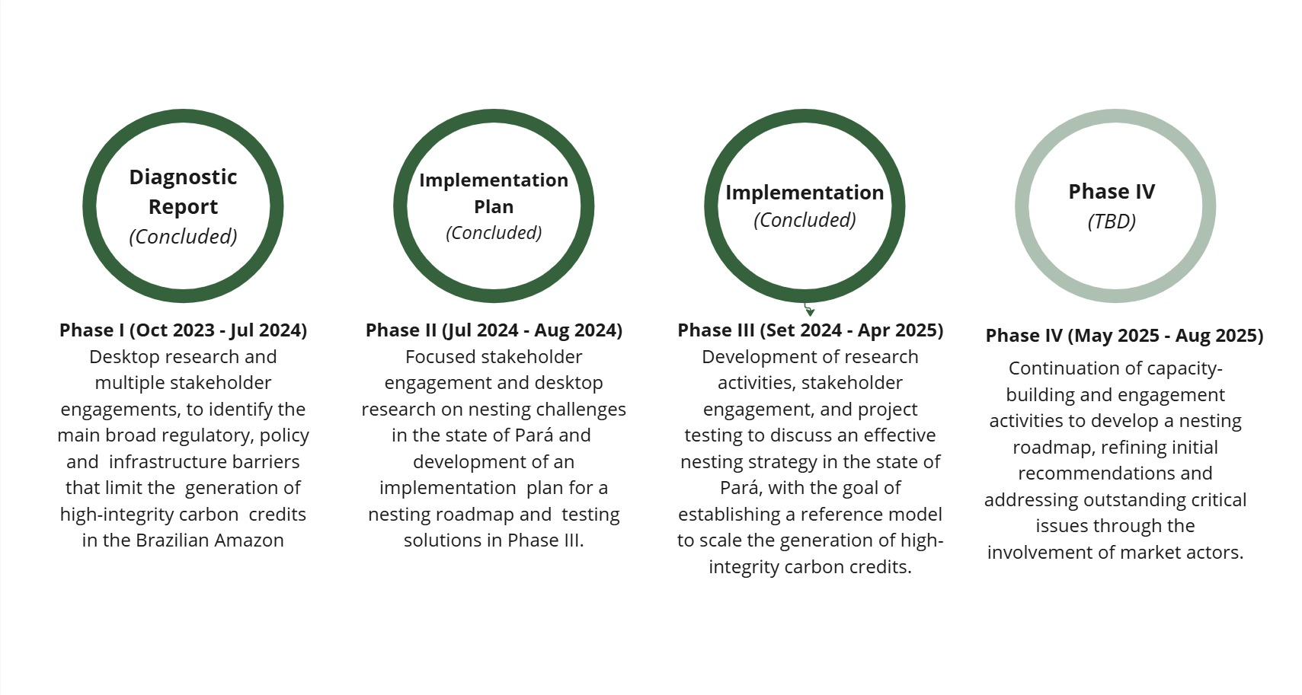

Figure 1 - Structure and timeline of ALMA Brasil project.

This report aims to summarize the main activities carried out, incorporating to the greatest extent possible the insights gathered throughout the research and engagement process, in order to provide inputs relevant to the context of the State of Pará. Based on the information collected so far, these inputs are intended to support the next phases of the project and the continued development of the State’s nesting strategy.

**Brief Context on Pará’s Jurisdictional REDD+ System[3]**

The State of Pará is establishing its Jurisdictional REDD+ System with financial support from Norway’s International Climate and Forest Initiative (NICFI). The process is coordinated by SEMAS, with technical support from TNC and IPAM, and involves joint development efforts with representatives from Indigenous Peoples, Quilombola communities, and Traditional Peoples and Communities (PIQCTs), including the Federation of Indigenous Peoples of Pará (FEPIPA), the National Council of Extractive Populations (CNS), and the Association of Remaining Quilombo Communities of Pará (Malungu). The system is supported by four main components:

* **Structuring a legal framework:** The construction of the legal-institutional arrangement aims to create a set of adequate structures to ensure legal certainty in the implementation of the REDD+ policy, in parallel with strengthening the governance system and creating an institutional arrangement that guarantees the participation of various sectors of society.
* **Creation of a financial mechanism:** In order to guarantee the viability and permanence of the REDD+ system's results, the state created Environmental Assets and Participations of the State of Pará (CAAPP), to facilitate the raising of funds to be reinvested in activities that reduce deforestation and value the standing forest.
* **Development of a safeguards information system:** One of the basic prerequisites for the Jurisdictional REDD+ System is the construction of socio-environmental safeguards, which contribute to guaranteeing the rights and participation of local communities and ensuring fair access to benefit-sharing. To this end, the state is developing its Safeguards Information System (SISREDD+ Pará).
* **Structuring an MRV system:** Composed of a set of techniques and methodologies that serve to verify the emission reductions reported by the jurisdictional REDD+ system, it is under development by the state through its technical partners.

1. **Methodology**

The methodology was based on three main activities, which encompassed the selected key themes: accounting and MRV, safeguards, land regularization and other risks, and operational procedures. It's important to note that the topic of operational procedures was not initially prioritized in the action plan's structuring. However, it emerged as a result of the engagements carried out, becoming a theme to be addressed during Phase III, albeit with less depth compared to the other themes.

Regarding the main activities, they were designed to provide feedback to each other throughout the process, in order to support the suggestion of criteria for nesting within each of the key themes, generating insights throughout the entire workflow.

Phase III work methodology is pictured **Figure 2.**

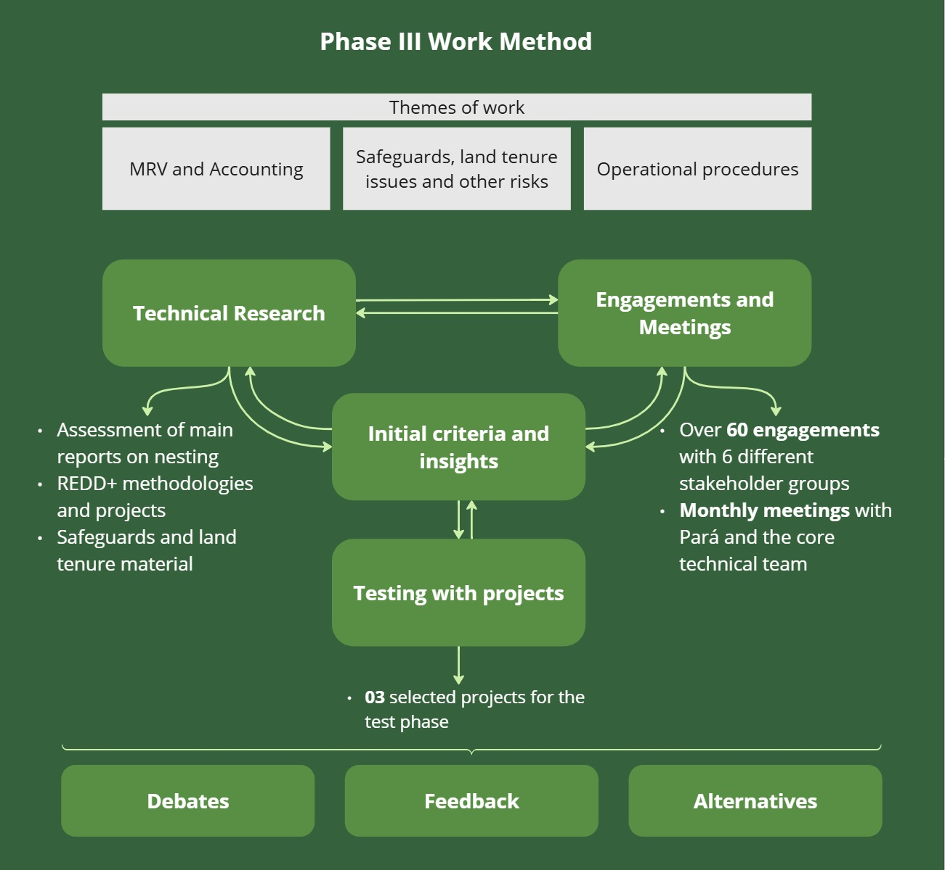

Figure 2 - Summary of the Work Method for Phase III of ALMA Brasil.

The **technical research** drew on publicly available documents as well as materials shared during stakeholder engagements, with the aim of understanding best practices and existing recommendations regarding the nesting of projects within jurisdictional systems.

The **engagements** served as the primary source of information and insights, as they functioned as an ongoing capacity-building process for all participants. These engagements enabled the comparison of information and interpretations around the differences between nesting approaches and fostered technical discussions on issues such as integrity, transparency, quality, legal certainty, among others. Engagements took place both in person—particularly with government institutions from the State of Pará—and virtually.

The main stakeholders engaged, across different categories, were:

* **Project Developers:** NBS Brazil Alliance, Ambipar Environment, BR Carbon, Carbonext, Hummingbirds, Systemica, Wildlife Works;
* **Standards:** ART TREES, Cercarbono, Verra;
* **Federal Government:** Ministry of the Environment and Climate Change – CONAREDD+, Forest Service;
* **State Governments:** State Secretariat for the Environment and Sustainability (SEMAS), *Instituto de Terras do Pará* (ITERPA), Interstate Consortium for Sustainable Development of the Legal Amazon, Acre Environmental Institute;
* **Market players:** C2050, CTrees, Emergent, Pinheiro Neto (law firm), Sylvera, Trench Rossi (law firm), UNDP;
* **NGOs:** IPAM, TNC, Winrock International, FAS.

In addition to these engagements, two meetings with the Advisory Board were held during Phase III, conducted jointly, and to further advance specific topics, bilateral meetings were also held with these stakeholders.

The research, technical meetings, and stakeholder engagements informed discussions around potential technical criteria to be applied to projects—preferably existing ones—that would be selected for the testing phase. Project selection was carried out via a public call for expressions of interest launched in November 2024. This call was shared directly by email with REDD+ project developers listed under Verra and operating within Pará, as well as with the coordination team of NBS Brazil Alliance, which represents over 70% of NCS project developers in Brazil.

The criteria used to select interested project developers are presented in **Figure 3.**

Figure 3 - Criteria and processes for selecting project developers.

Three companies expressed interest in participating in the collaboration and were engaged for the testing phase. The initial engagement process took place through a bilateral introductory meeting, during which the project's purpose and expectations for the testing phase were explained. At that time, a Non-Disclosure Agreement (NDA) was also sent for review and signature, in order to safeguard the information shared by the companies. Following this, virtual forms [4]were sent to request specific information, which was later supplemented by bilateral meetings to clarify questions and gather general feedback. As of the closing of this report, the responses submitted by Ambipar Environment and Carbonext were considered.[5]

It is important to reiterate that the goal of the testing process is to understand how the projects would perform under certain potential decisions by the state on the topic of nesting, across the three selected workstreams. The considerations raised were included anonymously in this report. It is worth noting that some tests still require further development of the potential nesting criteria to be tested, in order to better understand their impacts.

Based on all the insights and information gathered, Phase III was concluded with the compilation report of the discussions presented here. The sections are organized as follows:

* **Research and engagement**: introduction to the specific topic, based on a broad review of the subject and a detailed analysis of the situation in the case of Pará, along with key points gathered from stakeholders during engagement activities.
* **Criteria identification and insights collection**: explanation of the specific discussions held to define nesting criteria, highlighting progress and outstanding issues in each area, as well as comments on the insights obtained during testing and initial meetings with selected project developers.
* **Initial discussions and proposals**: summary of the main discussions on the topic and an overview of some initial proposals considered throughout the process.

1. **Challenges faced and resulting adaptations**

Given that this initiative involves a range of stakeholders with different roles and operational dynamics, it is natural that changes arise along the way, requiring adjustments and adaptations to better accommodate unforeseen events and ensure the continued efficiency of activities.

For this reason, it is important to highlight some of the key challenges faced during Phase III of ALMA Brasil, which led to adjustments to the initially planned activities **(Table 1**).

Table 1 - Key Challenges Encountered in Phase III and Adaptations to Planned Activities.

| **Planned** | **Challenges** | **Executed** |
| --- | --- | --- |
| Development of nesting criteria based on an initial version by October 2024, to be tested between November 2024 and January 2025, with the goal of refining a second version to be presented to the state. | Different timelines of activities between the state and its associated stakeholders. Many efforts were focused on the registration submission document and interactions with ART TREES, as well as public hearings and other priority actions. Specifically for the accounting component, one of the main challenges was the extended timeline for hiring experts to run allocation scenarios. | For the accounting and MRV component: discussions of main points of agreement and divergence based on engagements, including insights from project developers.  For safeguards and land tenure: development of initial criteria and collection of feedback from shared forms.  For operational procedures: collection of initial perspectives from the state and selected developers. |
| Selection of up to three projects to test the developed criteria and gather feedback for the process. | Differing expectations regarding interaction and collaboration throughout the process—both from the state and developers—led to initial difficulties in coordinating engagement with the project and to extended timelines for information sharing and feedback collection. | Conversations advanced primarily with two of the three companies that expressed interest, though not all testing stages were completed, as initial responses were only made available in April 2025. Insights and perceptions were included anonymously in the report. |
| Consolidation of suggestions from testing and discussions. | Develop recommendations based on research and testing processes to arrive at minimum requirements for each theme. | The report presents progress, challenges, and next steps for each theme; however, it does not yet provide final recommendations for the process. |

Thus, this report aims to compile the progress made by ALMA Brasil during Phase III, considering the necessary adjustments and highlighting key points to be prioritized in the next phase. It is important to emphasize that the adaptation of activities and timelines is to be expected in a complex process involving multiple stakeholders and diverse interests. Nonetheless, the research and engagement processes carried out provided the flexibility needed to manage such unforeseen developments and ensure concrete progress toward the goal of informing the development of an efficient and high-integrity nesting strategy for the State of Pará.

1. **Discussions on Nesting Requirements**

This section aims to present and discuss the key topics studied for nesting: accounting and MRV, safeguards and land tenure regularity, and operational procedures. The information discussed here results from a compilation of research findings, collected through technical meetings and engagements, or through information obtained from initial project tests.

## 4.1. Accounting and MRV

Undoubtedly, one of the central discussions regarding the coexistence of jurisdictional projects and programmes in the same territory is the possibility that the same emission reduction from avoided deforestation or degradation could be counted more than once. Therefore, the risk of double counting is one of the central factors in promoting nesting strategies.

From an accounting perspective, nesting projects into programmes means ensuring that credits generated by projects are properly deducted from jurisdictional programmes. However, this process represents a challenge that has persisted for many years in studies and debates, as there are significant differences in the approaches to estimating, monitoring, and verifying emission reductions in specific territories (projects) versus an entire landscape (programmes).

Thus, in this section of the report, we will discuss the main differences between how the state of Pará is quantifying its reductions compared to how existing projects in its territory quantify them, as well as assess the current state of projects and the potential impacts of different accounting nesting scenarios both for projects and the state, to enable progress in the discussion of potential proposals on this topic. Additionally, transversal issues such as alignment with national strategies will also be evaluated.

### 4.1.1. Research and engagement

In the logical sequence of research and discussions on the topic of accounting nesting of projects into programmes, the first item that deserves attention is how a jurisdiction defines its baseline and, from that, promotes nesting with the baselines defined for projects.

The way countries establish their forest emission reference levels dates back to the Warsaw Framework, established at the 19th Conference of the Parties (COP 19). In this context, the UNFCCC defined a set of rules for countries to establish their emission reference levels or reference levels transparently, considering historical data and adjusting them to national circumstances. Brazil submitted its first reference level (FREL) to the UNFCCC in 2014, and has been reporting its results since then.

**Figure 4** presents a simplified representative scheme of how the different possibilities for mitigation activities, including REDD+, are structured and related in Brazil, based on the prerogatives of the Warsaw Framework. It indicates that the possibility of accounting for carbon credits from subnational jurisdictional programmes exists within a specific percentage (60% of national results), as established by Resolution No. 06, dated July 6, 2017, from the National REDD+ Commission (CONAREDD+). Beyond this division between the federal and state levels, there is also a second distribution of such results among states, depending on each state's forest representativeness. How carbon projects fit into this process and what types of credits may be considered for the SBCE and/or Article 6 is still under discussion. However, this structure and its evolution are important to consider during debates on aspects related to jurisdictional programmes, both with states and CONAREDD+, as they may eventually impact the demand and supply of credits, as well as the feasibility of programmes and projects.

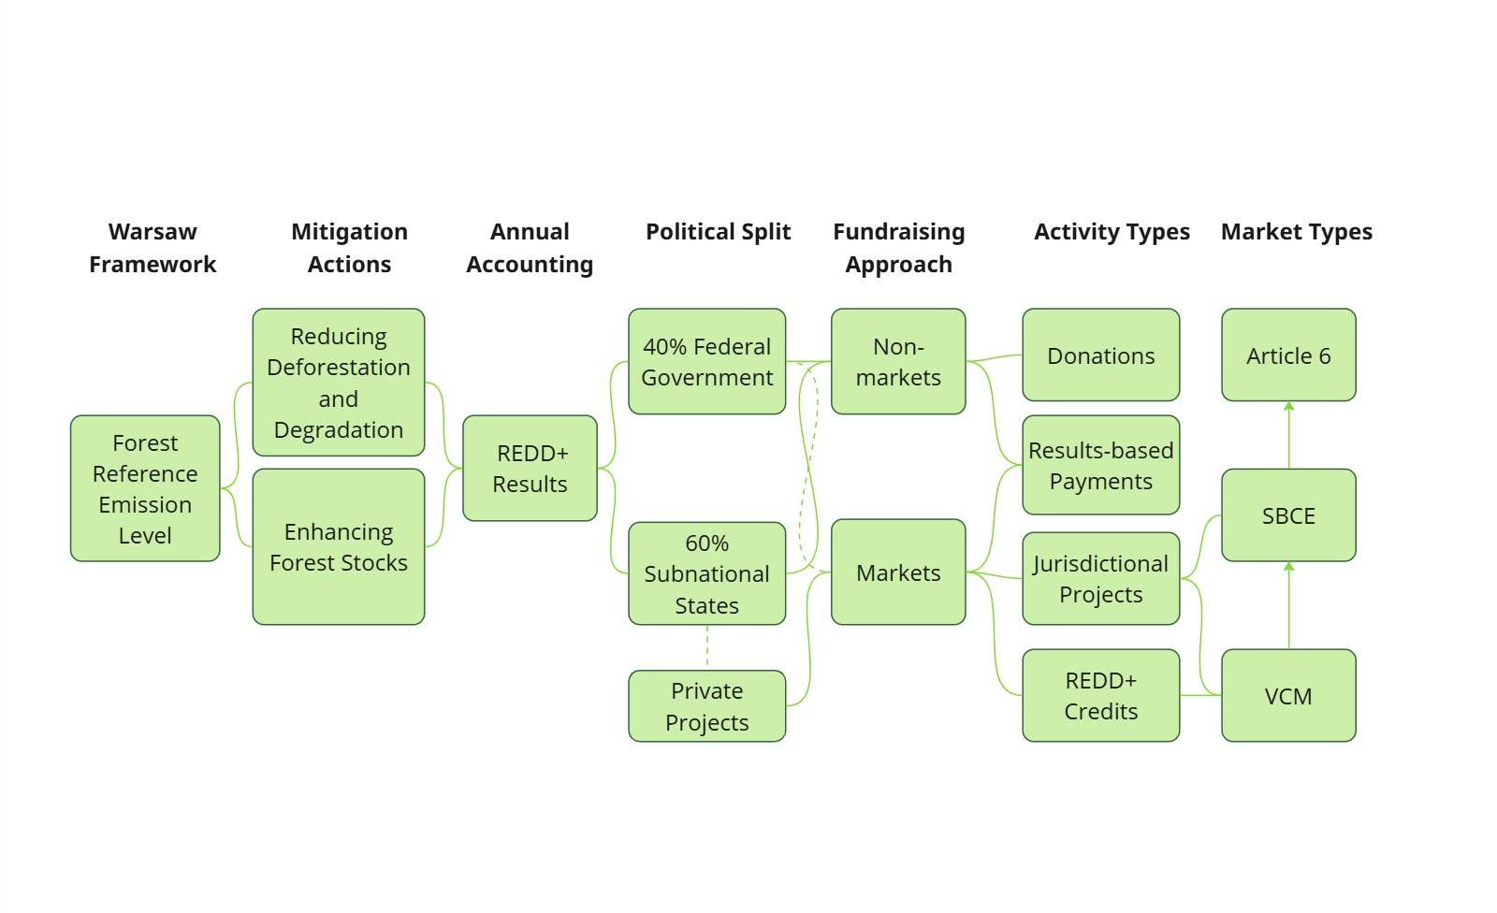

Figure 4 - Summary of market and non-market possibilities for REDD+ actions in Brazil.

Currently, there are two main methodological options for jurisdictions to structure their REDD+ programmes with the aim of generating credits: TREES, belonging to the Architecture for REDD+ Transactions (ART), and the Jurisdictional Nested REDD+ (JNR) framework developed by Verra.

ART TREES was created so that countries and subnational jurisdictions can become eligible to generate verified reductions and removals, by meeting specific requirements for accounting and crediting, independent monitoring and verification, leakage and reversal risk mitigation, ensuring no double counting, and providing robust environmental and social safeguards, all with transparency in processes and transactions.

The TREES methodology, considered flexible to meet the specificities of jurisdictions, has become the preferred standard for structuring jurisdictional programmes worldwide, with 26 programmes in various stages of development within its registration platform.

The JNR, on the other hand, is a framework proposed by Verra, with a focus on promoting nesting between programmes and projects, specifically for REDD+. It was designed in accordance with the guidelines established for REDD+ by the UNFCCC and aims to harmonise programmes and projects, using as reference the REDD+ methodologies developed by Verra within the Verified Carbon Standard (VCS). Currently, there are four submissions to the JNR, at different stages of development (Argentina, Colombia, Myanmar, and Brazil – Acre).

Both methodologies have received approval from the Integrity Council for the Voluntary Carbon Market (ICVCM), making the credits issued by these programmes compatible with the Core Carbon Principles (CCPs). The ICVCM is currently the main reference organisation regarding market integrity and has been evaluating methodologies to endorse those that meet the principles assessing the quality and integrity of voluntary carbon market credits.

Additionally, both credits issued by ART TREES and credits from specific projects under the JNR framework – such as those linked to certain approved scenarios and methodologies – are eligible within the context of the Carbon Offsetting and Reduction Scheme for International Aviation (CORSIA), a sectoral emissions reduction programme that allows the use of voluntary carbon market credits for regulated companies (entities in the aviation sector) to meet part of their obligations, provided these credits are authorised and undergo corresponding adjustments according to the rules of Article 6 of the Paris Agreement.

ART TREES is much more widely discussed and adopted by jurisdictions in their various phases of implementation. One reason for this is that it is the programme accepted by the LEAF Coalition, a unique public-private partnership focused on financing the fight against tropical deforestation by 2030. It brings together governments of forested areas, the private sector, donor governments, local populations and communities, and civil society. In 2021, a memorandum of understanding was signed between the states comprising the Legal Amazon Interstate Consortium and the Coalition, paving the way for specific agreements to be made later, such as the one with Pará in 2024.

In terms of accounting, both methodologies refer to the use of national reference levels and present assumptions for nesting strategies based on scenarios. ART TREES does not prescribe how nesting should be implemented; however, it discusses five different scenarios that can guide jurisdictions in designing a program. These scenarios vary according to the level of government centralization or decentralization in credit issuance. Meanwhile, the JNR framework outlines three possible scenarios for programs, whether or not they include project nesting.

The state of Pará adopted ART TREES as the methodology for developing its state jurisdictional programme and has publicly published a concept note on the platform, dated 28 October 2024. However, with the support of its technical partners, the state has already been working on its registration document and the first monitoring report, with continuous contact with the ART team, in order to proceed with the verification process for these documents.

The main technical features of what is being proposed by Pará for its REDD+ Jurisdictional System with ART TREES are presented in **Table 2.**

Table 2 - Main Technical Features of the Pará REDD+ Jurisdictional Programme Proposed to ART TREES[6].

| **Aspect** | **Definitions for Pará JREDD+ System** |
| --- | --- |
| Representative organisation | Secretary of the Pará State of the Environment and Sustainability |
| Crediting period | 01/01/2023 a 31/12/2027 |
| Reference period | 01/01/2018 a 31/12/2022 |
| Accounting area (forest) | 86,336,068 hectares |
| Level of accreditation for 2018-2022 | 252.132.914 tCO2e |
| Reference for the level of accreditation | National FREL[7] |
| Data sources[8] | * Deforestation and degradation emissions (fire selective logging) – PRODES/DETER * Land use – TerraClass * Carbon stocks – national FREL database Projects of the estimates of Amazon Biomass (EBA)[9] |
| Adjustments in the national FREL made to Pará quantification | * Emissions from fire-related degradation were accounted for across the entire territory of the state, whereas at the national level, such emissions are only considered for managed forest areas. * Degradation emissions were considered for both unplanned selective logging and geometric selective logging (while in the national FREL only unplanned logging is considered)[10] * The degradation files were converted from vector to raster format to facilitate the use of the Google Earth Engine tool.   Carbon stock calculation was carried out on a per-pixel basis (wall-to-wall approach), whereas national accounting was based on the average stock of each reservoir per activity data polygon. |
| Forest definition | Characterised mainly by the density of trees in the upper canopy layer of the vegetation formations, where some trees may reach heights of up to or above 50 metres (in line with the national FREL). |
| Vegetation map | Classification by the Brazilian Institute of Geography and Statistics (IBGE), with forest and non-forest definitions based on the Global Forest Resources Assessment (FRA) 2020. |
| Minimum unities for mapping | Deforestation (PRODES): 1 hectare  Degradation (DETER): 3 hectares |
| Carbon pools | Aboveground biomass  Belowground biomass  Dead wood  Litter |
| Considered GHG | CO2, CH4 and N2O |

The use of national information and databases is a growing trend among jurisdictional programmes currently being considered or implemented. This approach helps ensure alignment across different levels (state–federal) and promotes greater security in accessing and monitoring information.

With regard to how projects design and quantify their baselines, there are currently two main voluntary market standards operating with REDD+ projects in Brazil and the state of Pará: Verra, through the Verified Carbon Standard (VCS), and Cercarbono.

The VCS is the leading voluntary carbon market standard used in Brazil and globally. It is part of Verra, a non-profit organisation based in Washington, D.C., which also oversees other environmental market-related standards. The VCS operates based on general guidelines applicable to all its projects and offers one or more methodologies tailored to each type of intended activity, accompanied by complementary guidance referred to as modules and tools.

In the context of REDD+ activities, the VCS includes the following methodologies:

* VM0006 – *Methodology for Carbon Accounting for Mosaic and Landscape-scale REDD Projects*, v2.2
* VM0007 – *REDD+ Methodology Framework (REDD+MF)*, v1.8
* VM0011 – *Methodology for Calculating GHG Benefits from Preventing Planned Degradation*, v1.0
* VM0015 – *Methodology for Avoided Unplanned Deforestation*, v1.2
* VM0048 – *Reducing Emissions from Deforestation and Forest Degradation*, v1.0

An important aspect of VCS methodologies for REDD+ is the distinction between planned (APD) and unplanned (AUD) deforestation and degradation. Projects associated with unplanned deforestation are more common; for this reason, methodology VM0015 has been the most widely used in Brazil to date. Methodology VM0007 is also highly relevant and covers both types of activities.

VM0048 is Verra's newly proposed methodology designed to replace the existing REDD+ methodologies. In recent years, REDD+ projects have faced scrutiny regarding their quantification approaches and potential overestimation of credits. From a project perspective, the logic used is that certain agents (known or unknown) increase the risk of deforestation in a given area – for example, the presence of nearby cleared land, roads, waterways, agricultural activities, logging, among others. These risks are assessed using so-called reference regions, which must be comparable to the area where a project is to be implemented. This risk is projected using historical data to estimate how long a conserved area would take to be deforested, and, after the necessary quantifications, results in the calculation of avoided emissions. It is worth noting that this is not the only factor leading to overestimated baselines, as the biomass values applied to the different carbon pools within an area can also result in above-average outcomes.

However, including deforestation pressure agents in reference regions can raise a project's baseline, resulting in a higher estimate of avoided emissions and, consequently, increased credit generation. Within this context, VM0048 has been developed by Verra to reduce the potential for overestimation by standardising and centralising quantification. It moves away from using project-specific reference areas. Currently designed only for AUD-type projects, this new methodology proposes baseline setting for each region by creating its own risk maps, using the allocation tool “VT0007 – Unplanned Deforestation Allocation Tool” and the quantification module “VMD0055 – Estimation of Emission Reductions from Avoiding Unplanned Deforestation”.

Verra is working with technical partners to collect data for jurisdictions worldwide to allow project implementation using this methodology as early as 2025. However, as of the closing date of this report, no projects were applying the methodology due to delays in data availability.

Another motivation behind VM0048's development is the intent to align efforts with the global growth of jurisdictional REDD+ programmes, as it proposes region-specific baselines. Additionally, the effort aims to ensure alignment with the national reporting level, which is also used in the context of the Paris Agreement.

Quantification under VM0048 combines module VMD0055 and tool VT0007 to estimate deforestation risks and allocate baselines to projects accordingly. **Figure 5** provides a summary of this process. It is important to highlight that these data and modules are, so far, only developed for the AUD approach and are being gradually published on Verra’s website.

Figure 5 - Steps for estimating deforestation risk and allocating baselines, as defined in VM0048.

In general, the VM0048 initiative was well-received by the market, given its aim to standardise processes. However, some important considerations need to be made:

* Initial comparisons conducted by independent studies show that, in most cases, the generation of carbon credits can drastically decrease with the application of VM0048. A study carried out by BeZero[11] tested the differences in 12 projects in the Brazilian Legal Amazon and noted the average reduction in the projected deforestation area from the old VCS methodologies from 1,200 to 370 hectares (a reduction of 70%). In engagements with developers, a similar pattern of information was observed: a variable reduction of 30 to 70% in credit generation, mainly shifting from VM0015 to VM0048.
* At the same time, the allocation according to the VT0007 tool could generate the opposite effect. During the engagements conducted, one of the issues brought up by developers is that risk factors do not include the presence of roads, which are considered significant drivers of deforestation in the territorial dynamics of the Amazon. Therefore, projects strongly influenced by the presence of roads are significantly impacted by the new methodology, with a reduction in possible credits, while areas that previously resulted in fewer avoided emissions, such as those with less road presence, see an increase in their credit generation potential with the new methodology.
* Although VM0048 has been active since November 2023 for AUD projects, for it to be applied, Verra must publish the final activity data, which are being produced gradually[12]. The first official data are scheduled for May 2025 for prioritised jurisdictions, which include the Brazilian Amazon states (excluding Maranhão and Tocantins).
* AUD projects using older methodologies will need to undergo a transition once the risk maps for the jurisdictions they are located in are published by Verra. The idea is that projects will have six months after this publication to adapt.

Thus, although VM0048 is seen as an improvement by the market, only after projects have been tested and verified will it be possible to understand the remaining challenges and whether it can be operationalised by projects. It is worth noting that there are still no modules for planned deforestation, creating a sort of limbo for projects adopting this approach.

On the other hand, the Cercarbono standard has a methodology applicable to REDD+ activities: "REDD+ methodology for the implementation of REDD+ projects consistent with national reference levels". The methodology is being adapted to allow REDD+ projects to integrate into jurisdictional programmes, aligning with national or subnational reference levels. Similar to the methodologies applied to VCS projects, the baseline is built through the analysis of deforestation agents and causes, using historical remote sensing data, forest inventories, and bibliographic sources, prioritising consistency with official data. The risk of forest conversion is projected over time, reflecting the actual pressure on the intervention area.

The methodology places significant emphasis on methodological consistency in areas that overlap with FRELs. In such cases, it is necessary to rebuild the project's baseline to ensure that calculations are representative of the specific area, even if they are based on the same national guidelines. This approach ensures the maintenance of environmental integrity and avoids double-counting in the accounting of avoided emissions, thereby reinforcing the reliability of the results for both the voluntary market and national climate commitments.

The definition of the historical period is another key point of the methodology. Cercarbono requires the use of at least 10 years of data prior to the start of the project for analysing trends in deforestation or forest degradation. Additionally, the projected baseline must cover the entire duration of the project, which must be at least 30 years. The methodology also requires that the baseline be updated every 5 years to incorporate new information on deforestation pressures and changes in the territorial context.

In summary, quantifications in program and project scenarios follow distinct approaches, whether in terms of establishing the main assumptions (reference period, deforestation agents) or in the data and methods used (data sources, estimation methods based on available information). Thus, nesting the accounting of these scenarios has become one of the main challenges in the coexistence of programs and projects, in the context of how to avoid double counting in quantitatively non-comparable methods.

A report from the World Bank (2021), focused on recommendations for nesting, provides several options for how governments can work to address these differences (**Table 3**).

Table 3 - Accounting nesting options from the second recommendations of the World Bank (2021).

| **Approach** | **Advantages** | **Risks** |
| --- | --- | --- |
| **Option 01:** the government can try to minimize the variation by limiting the methodologies accepted for nesting, as well as their application (including models, data sources). | A simpler and more direct approach. The definition of project baselines is done more locally and tends to provide refined results | It may reduce risks but does not eliminate discrepancies in accounting and potential overestimations. |
| **Option 02:** The government can allocate the state-level FREL to smaller scales, i.e., develop its risk map and allocate emissions to projects based on it. | This ensures that the project baselines do not exceed the jurisdictional baseline, offering greater alignment between the scales. | Technically, it is more challenging, as it needs to provide the risk to the projects. |
| **Option 03:** The government can propose a maximum credit emission level per project, based on a quantification that determines this maximum number. | Less technically challenging, as it establishes an objective guideline for the limit. | However, it does not result in an alignment of baselines and may impact projects in very distinct ways. |

In relation to how other jurisdictions have been addressing these challenges, in Peru, for example, a centralised model was adopted, in which the project developer receives resources through the government. The RENAMI (National Registry of Mitigation Measures), linked to the MINAM (Ministry of Environment), issues credits corresponding to the quotas accounted for according to the FREL. Among the legal instruments supporting the system are resolutions no. 156-2022 and no. 011-2022 from MINAM.

In Guatemala, the importance of projects, such as those issued by the VCS, is recognised. However, the government has proposed a system in which several stages will be used for the allocation of quotas to projects wishing to be nested, based on the national FREL of the jurisdiction. A transition period was established until December 2020, during which projects already registered on these platforms could issue their credits, which would be fully deducted from the government programme. After this, the issuance of credits by voluntary markets would not be allowed while the agreement between the project and the jurisdictional programme remained in force.

It is important to highlight that the state of Pará has indicated that it will not adopt a centralised approach, which is quite distinct from existing programmes worldwide. Therefore, these examples are useful for understanding the nuances of nesting; however, there is no well-defined model that could be replicated for the case of the Brazilian state in question.

A second crucial point discussed regarding accounting nesting is the source of data used for the estimates. These tend to be different across methods for various reasons. International certification standards, for example, operate globally, and therefore choose to adopt broader data sources that can provide quality information in a standardised way across different jurisdictions.

One of the main issues with nesting projects that intend to adopt the VM0048 methodology in the state of Pará, for example, concerns the discrepancy in data sources. The VM0048, within its modules and tools, is built using data provided by various partners, including NASA, to monitor and validate emission reductions. These data are crucial for the accuracy and integrity of the carbon credits generated by the projects. In contrast, the Brazilian FREL, and the FREL adjusted for the state of Pará, use data from PRODES/DETER, which are not accepted by Verra.

In a technical note, Verra explains the differences between the data[13]. In summary, although PRODES uses a consolidated method for deforestation monitoring in Brazil, its scope and definitions are not aligned with the data requirements of VMD0055 of the VCS. A summary of this analysis is presented in **Table 4.**

Table 4 - Differences between the requirements of the VMD0055 module and the PRODES/DETER databases.

| **Requirements VMD0055** | **Discrepancy Observed in PRODES/DETER Data** |
| --- | --- |
| Data collected based on the national definition of forest (0.5 ha, 5m height, 10% canopy cover). | Minimum mapping resolution of 6.25 ha. |
| Emissions from deforestation should include deforestation that occurred not only in primary forests. | It does not account for deforestation of secondary forests or progressive deforestation — processes that are often precursors to clear-cutting. |
| Historical activity data must be estimated through a sampling-based approach, with human interpretation of high-resolution images within sample plots, conservatively adjusted based on the estimated statistical uncertainty, and then annualized. | It does not provide statistically calculated uncertainty margins and conservative adjustments when appropriate, and it does not directly address human activity data. |

### 4.1.2. Identification of criteria and collection of insights

To think about accounting nesting strategies for projects within a REDD+ jurisdictional programme, using the state of Pará as a case study, several guiding questions were posed:

* What are the main methodological differences between the various approaches, and how can they be overcome?
* Is it possible to measure the impact of projects within Pará's REDD+ Jurisdictional System or vice versa? What are the paths for such analysis?
* What are the main barriers still present for the accounting nesting of projects into the state programme?
* What is the landscape, challenges, and perspectives of nesting, considering the federal context?

Although some of these points were addressed in section 4.1.1, particularly regarding the different existing methodological structures, it is important to discuss some of the different opinions gathered during technical engagements, supported by distinct analyses.

Considering that these differences exist, the various technical engagements conducted during the third phase of ALMA Brasil sought to understand the possible impacts of nesting. In this sense, it became clear that a key step for enabling debate and future decisions about how to nest project accounting within the proposed programme is the development of a risk map for the state of Pará. It is understood that this is a necessary diagnosis to understand the crucial differences between the project and programme estimates and the possible scenarios from this.

In general, companies developing or intending to develop REDD+ projects in Brazil, particularly in the Amazon, have been preparing for the two main trends: the evolution of subnational jurisdictional programmes and the methodological transition to VM0048, given that these changes have the potential to cause significant impacts on the projects, with a possible need for adjustments to ensure the economic viability of such projects. Both changes depend on very specific timelines – on the one hand, what level of priority states will give to nesting within the development of their jurisdictional structures, which involve a variety of other issues (technical, social, structural, regulatory), and on the other, what realistic timeline for standards such as Verra, in adapting and operationalising their methodologies that foresee the nesting of baselines and other quantitative adjustments.

Thus, some of the main insights from developers regarding accounting nesting refer to the different possibilities for thinking about this harmonisation. Simply put, the creation of a risk map should be able to predict two main aspects: the expected level of deforestation and where it is likely to occur. These aspects are based on the past to predict the future, which is why they use a historical period and a series of parameters that help to feed the predictive models. Some examples of these variables include: slope of the land, distance from cities, presence of conservation units, among others. It is also important to highlight that different types of land tenure are also subject to different deforestation pressures.

Regarding the analyses conducted by developers, perceptions vary. Considering the risk factors of deforestation, for instance, some technical opinions indicated that modelling based on deforestation history could be more advantageous than modelling that considers a variety of factors. This conclusion is based on the fact that, from a simpler premise (a single risk factor), the subjectivity of the analysis would be lower, resulting in greater consistency. By adopting fewer assumptions, analyses also allow, for example, the matching of different periods, in the case of baselines established in different time frames.

However, the measurement of this impact can only occur with the existence of such risk maps, even if they are not the final versions. In conversations with the state and its technical partners, previously conducted analyses were debated to consider potential deforestation risk factors across the territory. However, since the nesting topic has not yet been explored in depth within the activities of building the REDD+ Jurisdictional System for the state, the development of the risk map itself is only expected to take place in the coming months.

In this context, the state and its technical partners pointed out the possibility of conducting scenario studies that would enable the understanding of impacts, as well as supporting possible allocation decisions. Initially, this will be done through the hiring of a third-party company capable of conducting the analyses. During Phase III, several technical meetings were held with the C2050 Platform team, which aims to propose an agnostic model for assessing and proposing possibilities for the nesting of projects. Although the formal hiring of the platform has not occurred by the time this report was finalised, progress was made in designing some analyses to be considered.

A first proposed technical evaluation to be conducted was a comparative matrix of different methods for calculating deforestation rates, in order to generate a risk map. For this, some basic evaluation criteria would be defined: i. what the scopes are, both in terms of historical evaluation period and the territory (geography) considered; ii. the levels of precision; iii. what input data is necessary and where it comes from; iv. the complexity levels of the analyses; v. what flexibility exists in each of the methods, and vi. what kind of transparency is observed in each method. These comparisons would be made for the following methods:

* Map according to the C2050 method, considering FREL data, adjusted for the state of Pará;
* Map according to the VT0007 method, considering FREL data, adjusted for Pará;
* Map according to the VT0007 method, considering activity data provided by Verra, in the context of the VM0048 methodology.

This matrix would be accompanied by different weights for each of the criteria, depending on their importance, and the sum of the criteria would define the degree of suitability of the methodology for the Pará case. Additionally, this analysis would include an identification of the main similarities between the different approaches, an evaluation of strengths and weaknesses, and the identification of potential gaps. This represents an important step in a preliminary stage towards the development of the risk map itself, to empower the state regarding the challenges and opportunities of each option and support future decisions on the use of these methodologies and tools.

In a later stage of this comparative process, the following would occur:

* The organisation of all project data within the platform, specifying the types of methodologies adopted, the types of activities (for example, whether or not it includes management), the emission sources considered, the type of deforestation (planned or unplanned), in order to generate the estimates and quantifications for all projects in the territory, year by year.
* The organisation of state data, according to the chosen method, to enable the calculation of deforestation rates, the creation of one or more risk maps for testing, and comparison with project data, followed by scenario analyses for allocation.

Since the technical work described is still under development, it was not possible to advance with the analysis/definition of criteria and testing of impacts on existing projects regarding accounting and MRV. However, one way to understand the current situation is by reviewing the projects in the territory and how they are estimated for the first crediting period proposed by the state. This is being done in the documents being developed for submission to ART TREES.

According to the December 2024 versions of the registration document and the first monitoring report of the REDD+ Jurisdictional System of Pará, there are REDD+ projects in the territory in the public registers of Verra (VCS and CCB) and Cercarbono. **Figure 6** shows a total of 34 projects (Verra) and 10 projects (Cercarbono) within the Agriculture, Land Use, and Forestry (AFOLU) category. In the case of Verra, there are 29 REDD+ projects and 9 from Cercarbono. To understand which of these projects would be eligible to request accounting nesting in the same accounting period proposed by the state (2023-2027), some considerations were made, based on instructions from ART TREES: projects with special statuses such as "removed", "registration denied", "paused", or "under review" were excluded from the "eligible for nesting" classification, as they were understood not to be ready to be accepted by the registries within a short time. This resulted in 20 Verra projects and 4 Cercarbono projects being considered eligible for nesting. Among these, a second analysis was carried out to identify those projects that have already been verified and issued credits, resulting in 4 Verra projects and 1 Cercarbono project. This analysis is important because, once verified, the project has undergone further audits, which may indicate that it is closer to issuing new credits in the near future.

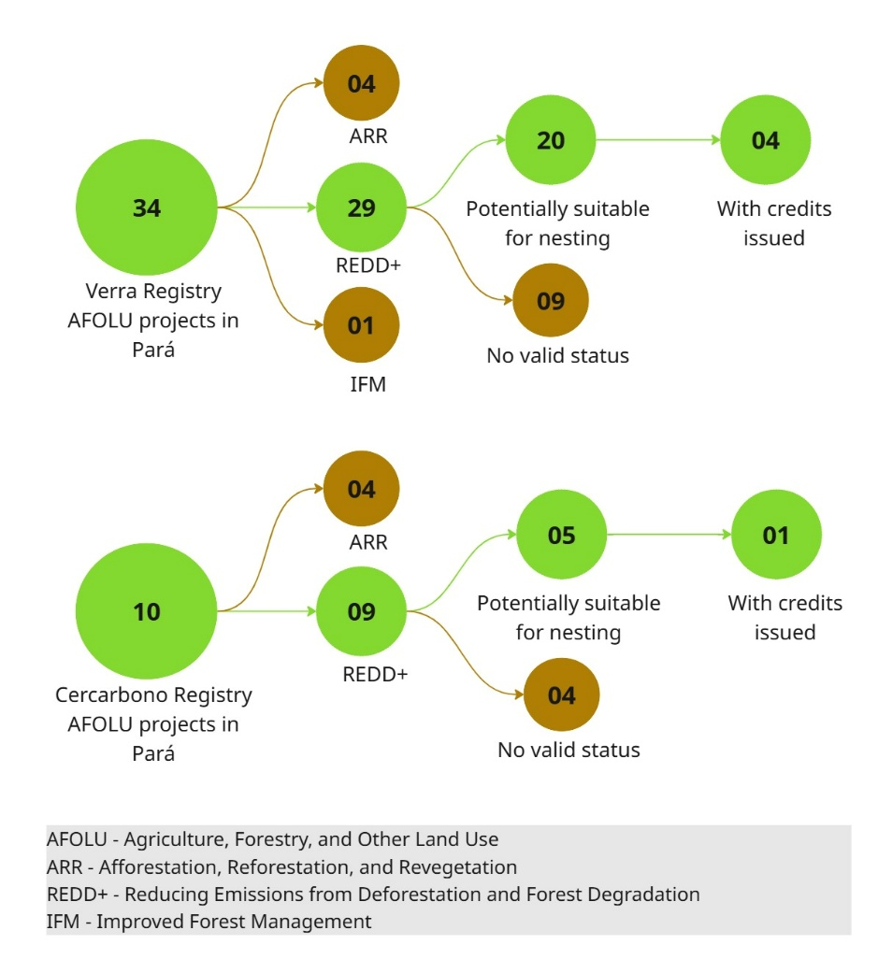

Figure 6 - Status of AFOLU Projects in the Territory of Pará – Verra and Cercarbono.

An assessment was made of the number of projects with potential for nesting, aiming to measure the possible impact of credit issuance in the context of the state’s Jurisdictional REDD+ System. **Table 5** shows the projects, by status, and the estimated credits for each of the years within the first crediting period proposed by Pará.

Table 5 - List of projects with potential for nesting in the Jurisdictional REDD+ System in Pará and emission reduction estimates between 2023-2027.

| **Platform** | **Project name (adaptation)** | **Status** | **Estimated Emission Reductions (tCO2e/year)** | | | | |
| --- | --- | --- | --- | --- | --- | --- | --- |
| **2023** | **2024** | **2025** | **2026** | **2027** |
| Verra | Cikel | Registered and with an issuance history | 1.008.420 | 1.008.420 | 1.008.420 | 1.008.420 | 1.008.420 |
| Ecomapuá | 150.514 | 150.514 | 150.514 | 150.514 | 150.514 |
| Floresta Verde | 235.405 | 235.405 | 235.405 | 235.405 | 235.405 |
| ABC Norte | 105.378 | 105.378 | 105.378 | 105.378 | 105.378 |
| AWA | Registration approved and verification requested | 503.182 | 503.182 | 503.182 | 503.182 | 503.182 |
| Tuerê | 862.557 | 862.557 | 862.557 | 862.557 | 862.557 |
| Jutaíuba | 600.694 | 600.694 | 600.694 | 600.694 | 600.694 |
| CAAPI | 228.338 | 228.338 | 228.338 | 228.338 | 228.338 |
| Cauxi | Registration requested | 190.881 | 190.881 | 190.881 | 190.881 | 190.881 |
| Ybyrá | 401.491 | 401.491 | 401.491 | 401.491 | 401.491 |
| Triunfo do Xingu | 110.887 | 110.887 | 110.887 | 110.887 | 110.887 |
| Agroflorestal Novo Horizonte REDD AUD PROJECT | Under validation | 94.143 | 94.143 | 94.143 | 94.143 | 94.143 |
| Curuaí | 105.789 | 105.789 | 105.789 | 105.789 | 105.789 |
| Ateles | 803.046 | 803.046 | 803.046 | 803.046 | 803.046 |
| Marajó | 298.409 | 298.409 | 298.409 | 298.409 | 298.409 |
| Serenity Valley | 251.636 | 251.636 | 251.636 | 251.636 | 251.636 |
| IWC | Under development | 500.000 | 500.000 | 500.000 | 500.000 | 500.000 |
| Ribeirinho | 1.521.662 | 1.521.662 | 1.521.662 | 1.521.662 | 1.521.662 |
| Sustainable FM | 99.696 | 99.696 | 99.696 | 99.696 | 99.696 |
| Together for the Forest Awaetê REDD+ Project | 1.294.534 | 1.294.534 | 1.294.534 | 1.294.534 | 1.294.534 |
| Cercarbono | Rio Jacareacanga | Registered and with an issuance history | 712.522 | 712.522 | 712.522 | 712.522 | 712.522 |
| Rio Crepori | Under verification | 427.257 | 427.257 | 427.257 | 427.257 | 427.257 |
| Alto Tapajós | Under validation | 255.682 | 255.682 | 255.682 | 255.682 | 255.682 |
| Rio Curuá | 270.019 | 270.019 | 270.019 | 270.019 | 270.019 |
| Rio Teles Pires | 245.527 | 245.527 | 245.527 | 245.527 | 245.527 |

It is important to note that, although credits are estimated for all years, by the closing date of this report, no credits had been issued for the listed projects in any of the registries for the year 2023, which is the first monitored period.

Thus, as the accounting for Emission Reductions or Removals by TREES (TREES ERRs) is based on verified data, Pará only has estimates for the year 2023. From a gross total of 57,888,754 tCO2e reductions estimated for 2023, excluding leakage, buffer, and uncertainty discounts, it is estimated that the state would be able to generate 34,859,507 credits in its first monitoring.

Considering all the estimated credit generation from the 25 projects listed in Table 5, the net value amounts to 11,277,669 tCO2e possible for the state in 2023. In other words, the projects represent an impact of 32.35% on the Jurisdictional REDD+ System in Pará (**Table 6).**

Table 6 - Accounting of current impact of Verra and Cercarbono projects in Jurisdictional REDD+ in Pará.

|  |  |  |  |  |  |
| --- | --- | --- | --- | --- | --- |
| **Assessed Program** | **Annual reductions estimates (tCO2e/year)** | | | | |
| **2023** | **2024** | **2025** | **2026** | **2027** |
| Pará JREDD+ System | 34.859.507 | - | - | - | - |
| Projects - Verra | 9.366.662 | 9.366.662 | 9.366.662 | 9.366.662 | 9.366.662 |
| Projects - Cercarbono | 1.911.007 | 1.911.007 | 1.911.007 | 1.911.007 | 1.911.007 |
| Remanescent credits for the state after discounting the projects | 23.581.838 | - | - | - | - |

Given the scenario presented, the state of Pará is proposing a full discount of credits from projects in its accounting for the first monitoring period, that is, adopting a 1:1 ratio. This is a provisional strategy to allow the state to implement its system while evaluating options for nesting. It is important to note that credits for 2023 have not been issued. Thus, the state would not be making a permanent discount but instead applying a contingency concept, not just for 2023 but for subsequent years, reserving such potential credits in a type of "savings", for later evaluation of the emission reductions that were actually verified by the end of the crediting period.

To advance the debate on the actual accounting alignment processes, it was found that, for the listed projects (i.e., excluding those not eligible for nesting), the impact in 2023 would be around 30%. This figure could vary significantly throughout the crediting period for various reasons:

* The state’s performance in controlling deforestation may vary due to climatic and political factors;
* The performance of projects may differ, either positively or negatively, from the ex-ante projections and ex-post verification;
* Depending on market conditions, there may be an increase in projects in the territory. This growth could stem from increased interest in nested projects if favourable and transparent conditions are created within the jurisdictional system.

Thus, the state needs to conduct scenario analyses that capture all these possibilities and facilitate discussions based on the results. Some pertinent questions in this regard are

* What will be the real impact of the transition of Verra projects, currently registered under the VM007 and VM0015 methodologies, during the adoption of VM0048? As mentioned earlier, studies so far have shown significant variation, with reductions ranging from 30% to 70% in most cases. If this is a trend for Verra projects, it is important to question whether a specific allocation strategy would be needed, or if the 1:1 discount could meet the state’s needs. However, since the methodology has not been applied yet and such large reductions have yet to be realised, it is still uncertain how the market will react, as projects could lose much of their financial viability without an equivalent compensation for the credits. In any case, conducting preliminary evaluations on how existing projects in the territory might behave under VM0048 is a crucial step for better planning of the system.
* What happens with projects that will not use VM0048? If the projected drastic reductions in emissions from projects upon adoption of the methodology hold true, one could consider the impact this might have on the market dynamics in the future. In this context, discussions held in Phase III considered the possibility of developing a procedure called “variance” within the ART TREES methodology, meaning that, in cases where a baseline is inflated or the volume of credits is incompatible with the size of an area and its vegetation profile, a methodological adjustment would be required from ART TREES to rectify these estimates. During engagements with various stakeholders on this topic, it became clear that variance requests are indeed possibilities explored by jurisdictions (and discussed with ART TREES), but they are tied to a slow process for evaluation and acceptance. It is important to note that variance requests can only be made to increase the conservatism of the approach or improve the accuracy of the data. In this case, the state must demonstrate that its approach is more conservative when considering such a strategy.

In addition to the points raised, a relevant issue in the context is the connection with federal regulations. Nesting or credit discounting is a methodological requirement of ART TREES and must therefore be observed by the state. However, following the approval of Law No. 15.042/2024, which establishes the Brazilian Emissions Trading System (SBCE), jurisdictional programmes must also observe Article 43, which recognises the original ownership of various types of land ownership (private, usufruct, indigenous communities, extractive and traditional communities, quilombola communities, beneficiaries of agrarian reform programmes, and other usufructuaries) over carbon credits generated. This allows any of the usufructuaries of these land types to request exclusion from jurisdictional programmes, provided they notify CONAREDD+ in advance. It should be noted that this law also mentions that CONAREDD+ must be informed of the methodology used or intended for use on these properties so that it can exclude them from national mitigation results and inform jurisdictional programmes of their obligation to remove the property from their programme. However, it does not clarify how to account for such exclusions and ensure consistency in accounting.

According to engagements conducted during Phase III of ALMA Brasil, this is one of the issues being studied by CONAREDD+ – how to define exclusion procedures and the related accounting, both concerning state jurisdictional programmes and national accounting.

Given that the criteria for accounting nesting have not progressed to the level of immediately comparing the credits that projects issue with what would eventually be allocated to these areas within the jurisdictional programme, it was decided during the initial testing phase with selected developers to focus on discussing the main issues and concerns about accounting nesting, summarised as follows:

* Nesting is a priority for maintaining REDD+ projects, and harmonising accounting is one of the urgent items to address this situation. Among the difficulties faced by developers, in terms of predicting the impact on projects, is the lack of clarity on the different approaches. The ART TREES methodology, for example, is quite flexible and allows states to develop their accounting based on national guidelines. There is a clear demand, especially from developers, for more detailed quantifications within the ART TREES framework during programme development.
* The proposal of VM0048 is positive, but it still generates many uncertainties. Developers are already testing hypotheses and applying the VT0007 tool to their projects to estimate the impact on credit generation. However, after the first activity data was released by Verra, significant discrepancies were found between the results obtained by developers and Verra, suggesting that adjustments are still needed in the data to be provided (for Pará, expected in May 2025). This creates an environment of uncertainty, not only in the estimates but also in the ability to operationalise the proposal in the short term.
* Regarding the questioning of different allocation testing options, such as using parameters like total area, biomass content, vegetation cover, or deforestation risk, the feedback emphasised that allocation based on the deforestation risk is the best technical option, as it more accurately reflects the actual situation of the project. However, it was also discussed that some simpler allocation options, such as assigning credit emission limits to specific land types (private, concessions, public land), are more political decisions rather than technical ones, as they allocate most credits to areas with the highest deforestation containment.
* There was a reinforcement of the usual concern with accounting nesting: harmonising different definitions and technical parameters, namely: forest definition, forest stratification methods, REDD+ activities considered, carbon reservoirs and greenhouse gases considered, methodologies applied to assess activity data and emission factors, methodological protocols, reference periods, baseline definition methods, and quantification rules. In this regard, while all these items are important, there is an understanding that the most critical issues are related to data sources and emission factors.
* To reassure the market about projects, there was also a discussion about reducing the periods for baseline revalidation (currently 6 years for Verra and 5 for Cercarbono), on the grounds that this would better represent reality.
* Considering discussions on the exclusion option for areas under the SBCE Law, there is a perspective that the 1:1 discount should be the state's preferred route.

Finally, although engagements with various stakeholders in the market indicated a positive perception of the creation of a jurisdictional programme as a tool that can leverage resources for combating deforestation in the state, it is important to note the need for greater understanding of aspects related to how benefit sharing will work within the jurisdictional programme, the additionality of the programme's actions compared to what was already being done in deforestation policies, and how to structure nesting in a way that does not harm projects when the jurisdiction’s performance falls below expectations or fails to materialise. It should be noted that, in the latter case, a broader debate should be promoted to prevent national performance differences from potentially hindering subnational efforts by limiting their credit generation.

### 4.1.3. Initial discussions and proposals

The information gathered, initial engagements, and feedback related to the topic of accounting nesting made it clear that this is the area of greatest concern within the broader perspective of project nesting. This is mainly due to its technical and political complexity in achieving harmonization and building consensus.

Throughout the engagements during Phase III of the ALMA Brasil project, there were numerous interactions and discussions with the state and other stakeholders regarding potential pathways for accounting nesting. In this process, the only confirmed procedure for adoption was the proposal of a 1:1 discount of already-issued credits for already-monitored periods (in this case, only 2023). While the state has technically indicated a preference for the use of methodologies, data sources, and emission factors derived from the national FREL, it has not established their mandatory adoption by developers.

In reality, these issues can only be better clarified through analyses capable of providing quantitative data to support decision-making. Since the state does not appear to intend to centralize the issuance and transaction of credits, the focus should be on advancing such quantifications to enable broader and technically informed dialogue, with the activities summarized in **Figure 7.**

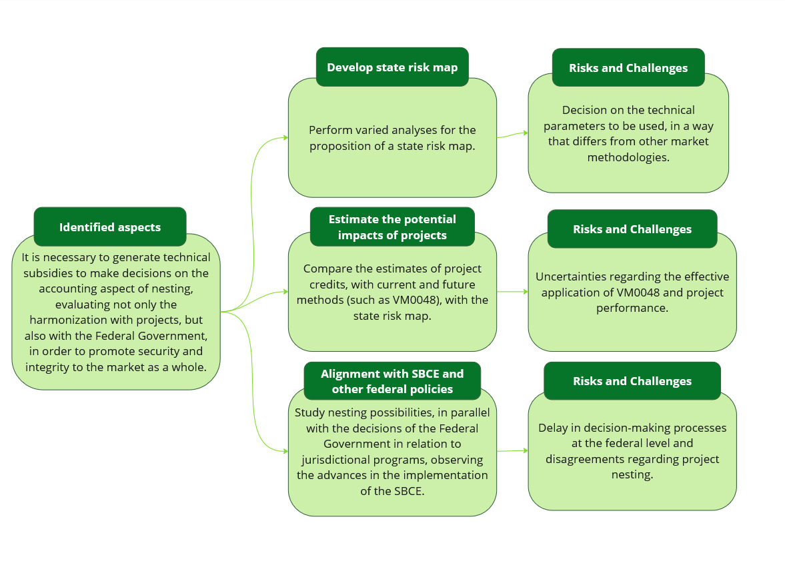

Figure 7 - Considerations on accounting nesting for the Pará Jurisdictional System.

If the state decides to adopt an allocation method different from the 1:1 discount initially applied in 2023, it is possible to consider establishing a transitional period—similar to what was done by the Government of Peru—during which that discount ratio would be maintained, allowing projects time to adapt. However, it is important to emphasize that, given the possibility of requests to exclude areas from jurisdictional systems, accounting conditions that encourage project nesting should also be considered. The goal is to foster the development of high-integrity and efficient jurisdictional programs, where the public and private sectors are complementary and capable of achieving better overall results in reducing deforestation.

## 4.2. Safeguards and land tenure

Safeguards are defined as guidelines aimed at maximizing positive impacts and minimizing negative impacts related to the actions of a given activity.

In the context of REDD+, the specific guidance for safeguards stems from the Cancun Agreements, which are based on three main objectives:

* To guarantee rights, especially of Indigenous Peoples and Traditional Communities (IPTCs), who are considered vulnerable;
* To promote the environmental integrity of achieved emission reduction results, avoiding displacement of deforestation-causing activities to other regions and preventing non-permanence or loss of carbon stocks in forests;
* To strengthen good governance, transparency, and participation.

Regardless of the approach (project-based or jurisdictional), these safeguards must be observed, adequately monitored, and verified. REDD+ activities inherently carry this concept, as they often involve Indigenous Peoples and traditional communities. Indeed, the lack of promotion of robust safeguards has been a target of integrity-related criticism in carbon markets globally — and in Brazil.

Thus, although certification programs or standards require the fulfilment of general minimum safeguards to ensure projects do not cause harm and deliver tangible benefits to stakeholders, some projects’ failure to implement appropriate actions — combined with the complex land tenure and socioeconomic realities in Brazil — underscores the need for public instruments that promote transparency and create structural conditions conducive to effective socioeconomic transformation in the regions where projects are developed, with due respect to Indigenous and traditional communities' rights.

Even though the nesting of safeguards does not affect the carbon accounting of projects or programs, it is a fundamental action to promote best practices across the territory.

This section explores the main differences in the definition of safeguards between programs and projects, presenting discussions on potential criteria to be met by project developers for nesting with the Pará jurisdictional REDD+ system, based on best practices and insights gathered during the project.

### 4.2.1. Research and engagement

The Cancun safeguards support what is expected from countries and their jurisdictions. These are:

**A**. Alignment between national and international forest policies

**B.** Transparent and effective governance structures

**C**. Respect for the knowledge and rights of IPTCs

**D**. Full and effective participation of stakeholders

**E.** Conservation of forests and biodiversity

**F**. Reversal risk mitigation (ensuring permanence)

**G.** Reduction of leakage risk (activity displacement)

These safeguards are supported by international, national, and subnational legal frameworks for their implementation, such as existing public policies, guidance, best practices, and regulations on anti-corruption, human rights, and respect for Indigenous Peoples and traditional communities.

The ART TREES methodology (version 2.0) requires that jurisdictional programs demonstrate a robust safeguard framework aligned with the Cancun safeguards. This framework is divided by themes to define the conditions required to address each specific safeguard. The program also includes the development of indicators to monitor safeguard performance. These indicators are categorized as:

* **Structural indicators:** Demonstrate that governance arrangements applicable to the jurisdiction are in place;
* **Process indicators:** Demonstrate that institutional mandates, processes, procedures, and mechanisms are effectively applied;
* **Outcome indicators:** Demonstrate the results of safeguard implementation in line with respect for rights and compliance with duties under international, national, and jurisdictional legislation.

For project developers implementing REDD+ activities, they must comply with the rules of their chosen certification standard. The Verified Carbon Standard (VCS) — the most widely adopted standard globally and in Pará — outlines its safeguard requirements in its current version, “*Verified Carbon Standard v.4.7*”.[14] This version includes a section on safeguards, addressing (i) Risks to stakeholders and the environment, (ii) Property rights and (iii) Ecosystem health.

Each topic includes specific guidance. VCS also contains a separate section regarding stakeholder engagement, particularly outlining procedures and reporting requirements for Free, Prior and Informed Consent (FPIC). Overall, VCS presents a distinct structure compared to the Cancun safeguards, although it touches on similar themes.

In addition to VCS, Verra also offers the Climate, Community and Biodiversity Standard (CCB), adopted by most recent REDD+ projects. It must be used in its latest version, “*Climate, Community and Biodiversity Standard, v.3.1”.[15]*

The CCB standard includes distinct sections for each component of its acronym (climate, community, biodiversity), each with specific indicators. Projects using both standards (VCS and CCB) typically provide more comprehensive information on safeguard-related topics. Notably, CCB claims alignment with the Cancun safeguards.

Another relevant standard in Brazil and Pará is Cercarbono, a Colombian certification program broadly used for projects in Colombia’s regulated market. Cercarbono has a specific document, “*Safeguarding Principles and Procedures of Cercarbono Certification Programme, v.2.0”[16]*, which outlines guidance for: Institutional safeguards, Governance structure recognition, Social and cultural safeguards, Respect for traditional knowledge and human rights, Effective participation, Environmental and territorial safeguards, Natural resource conservation and management, Leakage risk prevention, FPIC instruments and Mitigation and monitoring plans.

Land tenure regularity is typically included as part of the safeguard requirements regarding property rights. This is a critical issue for REDD+ projects, as there have been instances of rights violations — either through fraudulent documentation or through the infringement of rights of Indigenous Peoples and traditional communities sharing project territories.

All the standards mentioned require documentation to demonstrate property rights, in accordance with local legal frameworks. However, as global standards, they may not fully capture the specificities of a given country in their guidelines.

Verification of compliance is conducted by third-party accredited auditors, trained in the specific standard's requirements, to assess whether the project and its evidence meet legal and technical requirements in its jurisdiction. **Figure 8** summarizes the general process of carbon credit project validation and verification, indicating the steps where documents are submitted or required.

Figure 8 - General process of validation and verification of documents

Evidence is submitted not to the public but to the standard and the selected third-party verifier, who are Beyond voluntary market programs, it is important to understand how other mechanisms address safeguards.  
One such example is the mechanism under Article 6.4 of the Paris Agreement, also known as the *Paris Agreement Crediting Mechanism (PACM)*. It is designed to function similarly to the Clean Development Mechanism (CDM) under the Kyoto Protocol, allowing countries and companies to invest in emission reduction projects abroad and receive certified carbon credits (called A6.4ERs or MCUs). The decisions made under this mechanism will serve as important references for markets globally, especially in a context striving for greater market interoperability and convergence.

Therefore, in developing safeguard criteria for nesting projects within the Pará Jurisdictional Program, it is also important to consider the safeguard criteria proposed under Article 6.4, particularly those within its *Sustainable Development Tool*.[17] When analyzing how different jurisdictions are applying social and environmental safeguards in nested REDD+ systems, most have adapted the Cancun safeguards to their national context. However, operationalizing these safeguards remains a challenge. National institutions responsible for Safeguard Information Systems (SIS) often struggle to consolidate information from various actors and institutions. The SIS must be capable of integrating national, subnational, and project-level data. For effective compliance, countries must define responsible actors — such as project developers and landowners — and regulate how safeguard implementation and reporting should occur in nested projects.

International experiences reveal varying levels of institutionalization of safeguards in nested REDD+ systems. Peru has adopted a more structured approach, with studies underway to identify gaps between project-level Environmental and Social Management Frameworks (ESMFs) and the jurisdictional REDD+ program requirements, aiming for greater coherence across implementation levels. Guatemala has a national ESMF and acknowledges the importance of safeguards but lacks practical guidance for project-level implementation. The Democratic Republic of the Congo formally recognizes the obligation to implement safeguards but offers only generic regulations. While it defines carbon credit ownership based on land tenure, it lacks operational mechanisms to ensure safeguard implementation.

### 4.2.2. Identification of criteria and collection of insights

In structuring the nesting of projects into the Pará Jurisdictional REDD+ System, the following guiding questions were considered:

* How are the safeguards of the Jurisdictional REDD+ System structured, and how do they align with project-level realities?
* How do projects demonstrate compliance with these safeguards in the voluntary market?
* Which of these routines and pieces of information can be leveraged by the Jurisdictional REDD+ System, and which requirements are essential for nesting?

The development of the Pará Safeguards Information System (SISREDD+) is one of the prerequisites for accessing climate finance with high environmental integrity, from which the state must demonstrate compliance with its safeguards, aligned with the Cancun safeguards framework. This system is still under development, based on the ART TREES methodology. However, by the time this report was completed, the proposed system included 43 safeguard indicators, divided among structure, process, and result indicators.

In a preliminary assessment, the TNC team reviewed 23 indicators they considered applicable at the project level, as shown in **Table 7.**

Table 7 - Safeguard indicators initially listed for projects.

| **Structure Indicators** | **Process Indicators** | **Outcome Indicators** |
| --- | --- | --- |
| Compliance with forest legislation in line with state forest law | Implementation of sustainable forest management | Forest areas covered with sustainable forest management plans |
| Compliance with legislation to access information related to REDD+ actions according to national human rights standards | Implementation of the Forest Code | State territory with ecological-economic zoning |
| Compliance with legislation to prevent corruption related to REDD+ actions in line with national human rights standards | Implementation of active transparency measures | Effectiveness in resolving complaints and responding to access-to-information requests |
| Compliance with legislation to respect, protect, and uphold land tenure rights related to REDD+ actions | Identification and mapping of land tenure and property rights | Results of active transparency |
| Compliance with legislation on the rights of Indigenous peoples, quilombolas, traditional peoples and communities, and family farmers | Availability of channels for complaints and information requests | Results of Benefit Sharing |
| Compliance with legislation to ensure environmental and social benefit sharing | Forest governance spaces with civil society participation | Response to violations of land tenure rights |
|  | Promotion of informative, formative, and consultative procedures for Indigenous peoples, quilombolas, local communities, and family farmers |  |
|  | Recognition by SEMAS of community protocols |  |
|  | |  | | --- | |  |  |  | | --- | | Implementation of Benefit Sharing | |  |

Based on these established indicators, an assessment was made of how each one is currently required by voluntary market standards. The latest published version of the VCS standard (v4.7) was used as a reference. The assessment indicated in which section of the VCS standards the information would be found. To better exemplify the fulfilment of each specific indicator, a project developed in Pará was evaluated, with observations on how it reported the required items in the documents available in the Verra public registry and the evidence cited for each one.

Following this analysis, new meetings were held with the working group to present the findings. Overall, some key findings and discussion points included:

* The proposed indicators are to some extent covered in the assessed standard, some more explicitly and others more indirectly, as they may represent more regional aspects (e.g., ecological-economic zoning) or use different language from what is typically used in the market ("forest governance spaces with civil society participation").
* Regarding how developers demonstrate compliance with the requirements, it was noted that most of the referenced evidence in the texts is not publicly accessible in the Verra registry. This creates difficulty in understanding whether the stated information is truly being met. It was reiterated that validation and verification processes fall under the responsibility of third-party companies contracted to perform these evaluations, requiring prior knowledge of the specific territory, as they are the ones with access to full documentation and must determine whether it is sufficient.
* The way verifiers assess varying levels of evidence was also questioned. For example, when it comes to consultation with Indigenous peoples and traditional communities, is there a minimum number of agreements required to demonstrate the community's consent to a project?

Based on these discussions, it was understood that the 23 indicators are relevant but could be consolidated into a few key strategic items to ensure legal and reputational security in relation to nesting. Therefore, a proposal was developed for requirements that could cover such concerns. At this point, other questions were raised:

* Not every project needs to meet the same safeguards. For example, some projects on private lands may not interact with Indigenous peoples or traditional communities and therefore do not need to go through Free, Prior, and Informed Consent (FPIC). Similarly, projects not involving forest management do not need to demonstrate compliance with specific legislation for such activity. Hence, requirements should be waived for these specific cases.
* A traffic light system could be established to categorize the information provided by project developers for each requested item, where some evidence would be automatically accepted (green), others would raise caution or require additional information (yellow), and others would be considered insufficient (red).
* Verifying compliance with each item is demanding, so it is necessary to consider how the state will organize itself to assess such information. This led to the suggestion of creating self-declarations to be provided by developers for each requested item. These safeguards could then be accompanied by a random verification process by the state, using a set of evidence to be required at the time of project nesting request.

The suggestion of self-declarations sparked debate within the working group, recognizing they could enhance the process’s overall security, but also raising concerns about reputational risks if documentation is not reviewed and could later be questioned in investigations. As a result, for the testing phase, it was suggested that the first safeguards form should not include self-declarations or a scoring system, but rather a broader request for developers to explain how they meet each safeguard in their projects and to attach supporting evidence.

A second request made at this stage of the testing form was the alignment of the requested items with the Cancun safeguards, aiming to present a consistent narrative to developers regarding how the state reports its information. The requested items and the types of information and evidence provided are outlined in **Table 8.**

Table 8 - Suggested safeguard aspects and how project developers demonstrate them.

| **Aspect** | **Related Cancun Safeguards** | **Type of Information and Associated Evidence** |
| --- | --- | --- |
| Compliance with current legislation (including forest law) | A (Consistency with national forest policies) and E (Forest and biodiversity conservation) | Descriptive text demonstrating compliance, CAR registration, environmental and management authorizations |
| Compliance with legislation and international/national good practices related to human rights | C (Respect for the knowledge and rights of Indigenous Peoples and local communities) | Descriptive text of compliance, codes of ethics, compliance policies, and other relevant documents |
| Compliance with legislation and good practices to prevent corruption | B (Transparent and effective governance structures) | Descriptive text of compliance, anti-corruption policy, training materials, and related documents |
| Implementation of active transparency, complaint and grievance mechanisms, and information requests | B (Transparent and effective governance structures) | Descriptive text of procedures and available channels |
| Compliance with legislation and procedures regarding rights of Indigenous peoples, quilombolas, traditional communities, and family farmers | D (Full and effective participation of stakeholders) | Descriptive text of procedures, socioeconomic mapping, community engagement information |
| Compliance with legislation and procedures for benefit sharing | B and D | The tested projects did not include benefit sharing, as they did not involve Indigenous peoples or traditional communities. They only listed community-related project activities. |
| Assurance of permanence | F (Addressing reversal risks) | Descriptive text of fire control procedures, operational plans, and existing monitoring systems |
| Leakage risk reduction | G (Reduction of leakage or displacement) | Descriptive text of implemented activities and supporting documents (technical assistance and training) |
|  |  |  |

The initial analysis of the requested aspects and the responses from the testing phase showed consistency in how developers addressed the main topics. However, it's worth noting that the projects evaluated so far did not involve Indigenous populations or traditional communities, which reduces the complexity of safeguard-related processes and documentation.

Discussions on implementing a potential traffic light system progressed but were not concluded by the time of this report, as differing opinions remain regarding the level of information to be required and how it should be assessed. Further analysis is needed to refine these definitions.

An important topic was how to leverage existing tools within the state’s institutional framework to verify project information more automatically. SEMAS has several internal processes used for other purposes. One tool discussed was the "Green Seal," focused on agricultural activities, which compiles property information based on the Rural Environmental Registry (CAR). These data could be used, for example, to verify compliance with environmental legislation. Considering the proposed traffic light system, **Table 15 of Annex I presents** an example of an assessment that could potentially be carried out. If the state decides in favour of implementing a traffic light system, it is important to advance in defining its criteria to allow developers to undergo a more accurate testing of how their projects are classified under these aspects. Additionally, these parameters could help estimate potential positive social and environmental impacts beyond the required safeguards.

Regarding the feedback provided by developers concerning the information requested in the initial form, the main suggestion was to prioritize the most relevant data and avoid potential rework in evaluating documents. One of the main concerns is the possible delay in analysing documentation within the state system before nesting is authorized. This is a relevant issue since most of these projects depend on consistent cash flow to remain viable. In general, delays already exist on the part of the standards themselves, in addition to the average time required for validations or verifications to be concluded. In this regard, one of the suggestions from the testing phase was that the state consider accrediting standards and methodologies within its future nesting structure.

Projects following these pre-selected standards and methodologies could either be automatically approved in the system or at least partially approved, requiring fewer additional checks by the state. This request reinforces the fact that projects already undergo scrutiny by validators during their certification process. It is also worth noting that developers responded positively to the possibility of a self-declaration process.

Finally, a concern raised during the testing phase was the need to align the safeguards proposed by the state with those being developed by the CONAREDD+ working groups. This would ensure harmonization on the topic across different scales within the country.

**Safeguards Specific to the Demonstration of Land Tenure Regularity**

Although included under the safeguards item, the issue of demonstrating land tenure regularity was addressed separately by the working group due to distinct competencies among organizations and within the state itself.

This is a highly sensitive and concerning topic, given reports of land irregularities related to carbon credit issuance in the Brazilian Amazon, including in Pará[18].

From the outset, the state proposed preparing a list of land tenure documents to be requested from project developers to provide greater legal certainty to the system as a whole. This discussion recognizes the various categories of land ownership and how documentation can vary for each type, according to specific legislation. The following categories were identified:

* Private property;
* Agrarian reform settlements;
* Conservation units;
* Quilombola territories;
* Indigenous lands;
* Possession.

In engagements with specialized law firms[19], it was suggested that land tenure regularity could also be assessed using the traffic light system, based on the recognition that some documents can demonstrate rights and the absence of territorial conflicts and are more easily regularized within legal procedures. With the support of these firms, an initial discussion was held to determine which documents could be requested for each land category. The result of this discussion with the working group is presented in **Table 16** **of Annex 1.**

In discussions around the initially proposed list, SEMAS emphasized the need to involve ITERPA (Land Institute of Pará), as it is the official authority responsible for land regularization in the state. This engagement was formalized through a Specific Technical Cooperation Agreement, which is currently in effect. ITERPA responded positively to the prepared list but proposed working on an official publication to provide guidance to developers on the required documents to comply with national and state land legislation. This publication would not be specific to nesting but would apply to all projects developed in the state.

Although this initiative is relevant and welcome for the market, it is important to note that it is not specific to ALMA Brasil. However, it may be recommended that the state follow the guidelines from this future publication for its nesting proposal. This process should also involve broad discussions to ensure that such guidelines truly facilitate both high-integrity projects and land regularization in the state.

One discussion that emerged from these interactions involved the different roles and responsibilities that will need to be defined within the state’s internal structure. For example, there is debate over who would be responsible for requesting and evaluating land ownership documents in the configuration of the state’s Jurisdictional REDD+ System. This important topic is further explored in Section 4.3: Operational Procedures.

In the testing phase with developers, as with other safeguards, information was requested on how land ownership documentation is typically presented. Thus, the initial form sent to developers asked them to indicate the land ownership type and detail the due diligence process conducted for the projects.

As of the date this report was finalized, the information collected referred only to private areas with multiple owners, with a description of the list of documents used for verification being provided. However, the actual land documents were not made available for analysis, as this would require the involvement of all owners involved in the projects. In some cases, documents explaining the status of each piece of evidence and how it is being addressed were provided. Regarding the lists shared for routine due diligence, they are compatible with the information in **Table 16 of Annex 1.**

Another important point regarding land tenure is the opt-out provision foreseen by the SBCE, as previously addressed in this report. To request the so-called “opt-out” from a jurisdictional program, the applicant must demonstrate land ownership rights in accordance with the law. Therefore, alignment is needed between what the Federal Government, through CONAREDD+, will require in terms of proof of land ownership and what is being developed within the structure of the state of Pará.

### 4.2.3. Initial discussions and proposals

In summary, the discussions on the topic of safeguards revolve around a central question: what is the best way to ensure the legal, social, and environmental integrity of the projects that wish to nest, without overburdening, on one side, the project developers—by requesting duplicate information—and on the other, the state—by creating extensive routines for information verification, which may lead to excessive resource use and delays in meeting demands.

**Figure 9** summarizes the main discussions and options regarding the theme of socio-environmental safeguards.

A more conservative path would be Alternative 01: Full verification of safeguards, in which the state retains control over the verification of all information to be submitted by the developers. However, as discussed in the previous section, this option may demand a significant allocation of effort within the state's structure, especially in terms of human resources that would need to be trained for this purpose, in addition to the time required for such evaluations—something that could discourage the nesting of projects in the state.

Alternatives 02 (Sample-based safeguard verification) and 03 (Accreditation of VCM standards) represent ways to streamline the process, through protection and mitigation strategies—whether via the use of self-declarations and sample audits, or through the accreditation of standards and methodologies within the system. It is worth noting that in both cases, there is a reputational and legal risk of non-compliance with the established safeguards. However, it is also important to highlight that this is an inherent risk in the market, and the indicated strategies help mitigate such risks.

Another possibility would be the formalization of agreements with standards, for the creation of specific modules capable of responding to the local context. In this scenario, validation and verification would be the responsibility of auditors accredited by the standards but would follow more tailored guidelines. The state, in turn, could conduct random checks, and upon identifying irregularities, request the cancellation of nested credits or agreements signed with the standards.

It is also worth remembering that aligning the state's nesting strategy with internationally recognized integrity initiatives, such as the Integrity Council for the Voluntary Carbon Market (ICVCM) and its Core Carbon Principles (CCPs), should be an important factor to ensure the robustness of the jurisdictional program, promote interoperability of markets at different scales, and attract international investment.

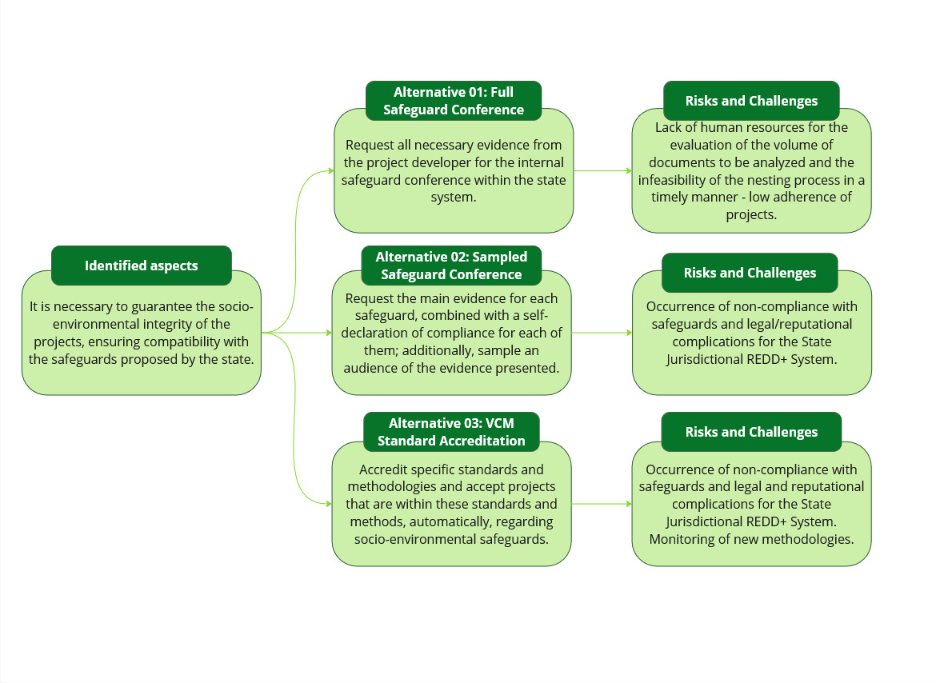

Figure 9 - Analysis of alternatives for safeguards.

## 

## 4.3. Operational procedures

The topic of operational procedures was included in the scope of ALMA Brazil during this phase of the project, given its importance in supporting the development of the discussions on the criteria in relation to the other topics. Although discussions on this matter have only just begun, the considerations presented in this section were discussed and are relevant to deepening the dialogue in subsequent phases of the project and informing future decisions on the subject.

### 4.3.1. Research and engagement

Considerations regarding operational procedures for REDD+ fall within a broader theme, which concerns the governance of the Jurisdictional System as a whole. In the context of nesting, such governance refers to regulatory frameworks and public policies related to forests, institutional arrangements, and decision-making processes that, in a coordinated manner, enable the integrated implementation of REDD+ initiatives within the same territory.

A study published by the UN-REDD+ initiative, from the United Nations Development Programme (UNDP)[20] compiled the key governance elements to be considered at different scales of REDD+ activity implementation (national, subnational, and project), divided into: policies, laws and regulations, and institutional arrangements. These aspects are presented in **Table 9, Table 10 and Table 11.**

Table 9 - Recommended key actions for nesting in the scope of policies, at different scales

| **Governance elements** | **Key actions in each scale** | | |
| --- | --- | --- | --- |
| **National scale** | **Subnational scale** | **Project scale** |
| Policies | * Develop or adapt a national registry to monitor nesting. * Strengthen and adjust MRV systems to integrate subnational and project-level data, defining appropriate protocols and methodologies. * Establish guidelines for credit transactions in domestic and international programs. * Establish benefit-sharing frameworks for subnational and local initiatives, aligned with the Cancun Safeguards. | * Align subnational regulations with the national strategy. * Strengthen subnational monitoring and regulatory agencies according to their roles in nesting (technical, operational, resources, capacities, among others). * Enhance procedures and capacities for implementing and monitoring safeguards within the nesting context. * Apply relevant land tenure regularization protocols. | * Develop specific guidance for project nesting. * Based on technical analyses and discussions with project developers, define methodological approaches to harmonize baselines at national and subnational levels. * Develop benefit-sharing plans, implementation mechanisms, and transparent communication channels with stakeholders, aligned with national and subnational scales. * Align safeguard management with national and subnational guidelines. |

Adapted from: UNDP, 2024.

Table 10 - Recommended key actions for nesting in the scope of laws and regulations, at different scales.

| **Governance elements** | **Key actions in each scale** | | |
| --- | --- | --- | --- |
| **National scale** | **Subnational scale** | **Project scale** |
| Laws and regulations | * Conduct a legal review of REDD+ elements for nesting, capturing national developments as well as other priorities and climate commitments. * Establish a multi-level framework capable of implementing the REDD+ strategy at different scales, with alignment and adaptation of elements such as MRV, benefit-sharing, among others. * Clarify how property rights—both over credits and over land—can be managed within the nesting framework, and define mechanisms to resolve potential conflicts. * Facilitate inclusive stakeholder dialogue to ensure that their inputs are incorporated in a manner consistent with legal requirements. | * Review and adapt subnational regulations to align with national and local contexts. * Develop and implement legal frameworks that recognize property rights based on national and subnational approaches. * Ensure subnational enforcement of national laws. * Establish coordination among subnational and local efforts regarding grievance mechanisms, benefit-sharing, and territorial dispute resolution. | * Develop legal guidance for project developers in compliance with national and subnational laws. * Establish clear guidelines, tools, and protocols for projects in the context of nesting. * Ensure legal support and capacity-building for Indigenous Peoples and traditional communities to guarantee the enforcement of their property rights. * Implement participatory processes concerning the intended legal framework. |

Adapted from: UNDP, 2024.

Table 11 - Recommended key actions for nesting in the scope of institutional arrangements, at different scales.

| **Governance elements** | **Key actions in each scale** | | |
| --- | --- | --- | --- |
| **National scale** | **Subnational scale** | **Project scale** |
| Institutional arrangements | * Establish permanent, multi-stakeholder platforms for decision-making, oversight, and coordination of REDD+ activities, integrated with other climate-related policies. * Develop channels for dialogue and conduct capacity-building to ensure access to information across different information flows, focusing on the integration of various government agencies. * Establish a coherent approach among different stakeholders to ensure safeguard implementation, capturing needs at subnational and local levels during the design and implementation of nesting strategies. * Support the coordination process to establish a REDD+ registry system that facilitates information access and distribution. | * Implement capacity-building activities on REDD+ and carbon markets to address potential conflicts and design spaces for dialogue between subnational authorities and other stakeholders. * Establish a dedicated subnational coordination body to oversee nesting activities. * Facilitate stakeholder interaction for nesting implementation and support the inclusion and review of safeguards, benefit-sharing, and other REDD+-related actions. * Identify agencies responsible for handling grievances and complaints related to nesting, within the structure of the Jurisdictional REDD+ System. * Establish the institutional arrangements needed to manage and distribute benefits. | * Integrate technical and administrative requirements requested by the federal government and demand-side actors (donors, investors, crediting programs). * Conduct participatory consultations and workshops to understand the implications of national and subnational frameworks for Indigenous Peoples and traditional communities. * Report emission reductions and benefit-sharing outcomes to national and subnational authorities. * Develop grievance and complaint mechanisms compatible with those proposed at the national and subnational levels. * Implement necessary safeguards at the project level, aligned with national and subnational requirements. |

Adapted from: UNDP, 2024.

In summary, the aspects discussed in the tables refer to items previously addressed in this report regarding the need for coordination of efforts at the national, subnational, and project levels across different thematic areas. However, it is important to understand the stage of development of Pará’s governance structures and to identify the outstanding issues related to policies, laws and regulations, and institutional arrangements as they pertain to nesting.

### 4.3.2. Identification of criteria and collection of insights

To guide the discussion on the development of a nesting governance framework for the state of Pará, the step-by-step approach suggested by the UNDP (2024) was chosen (**Figure 10**).

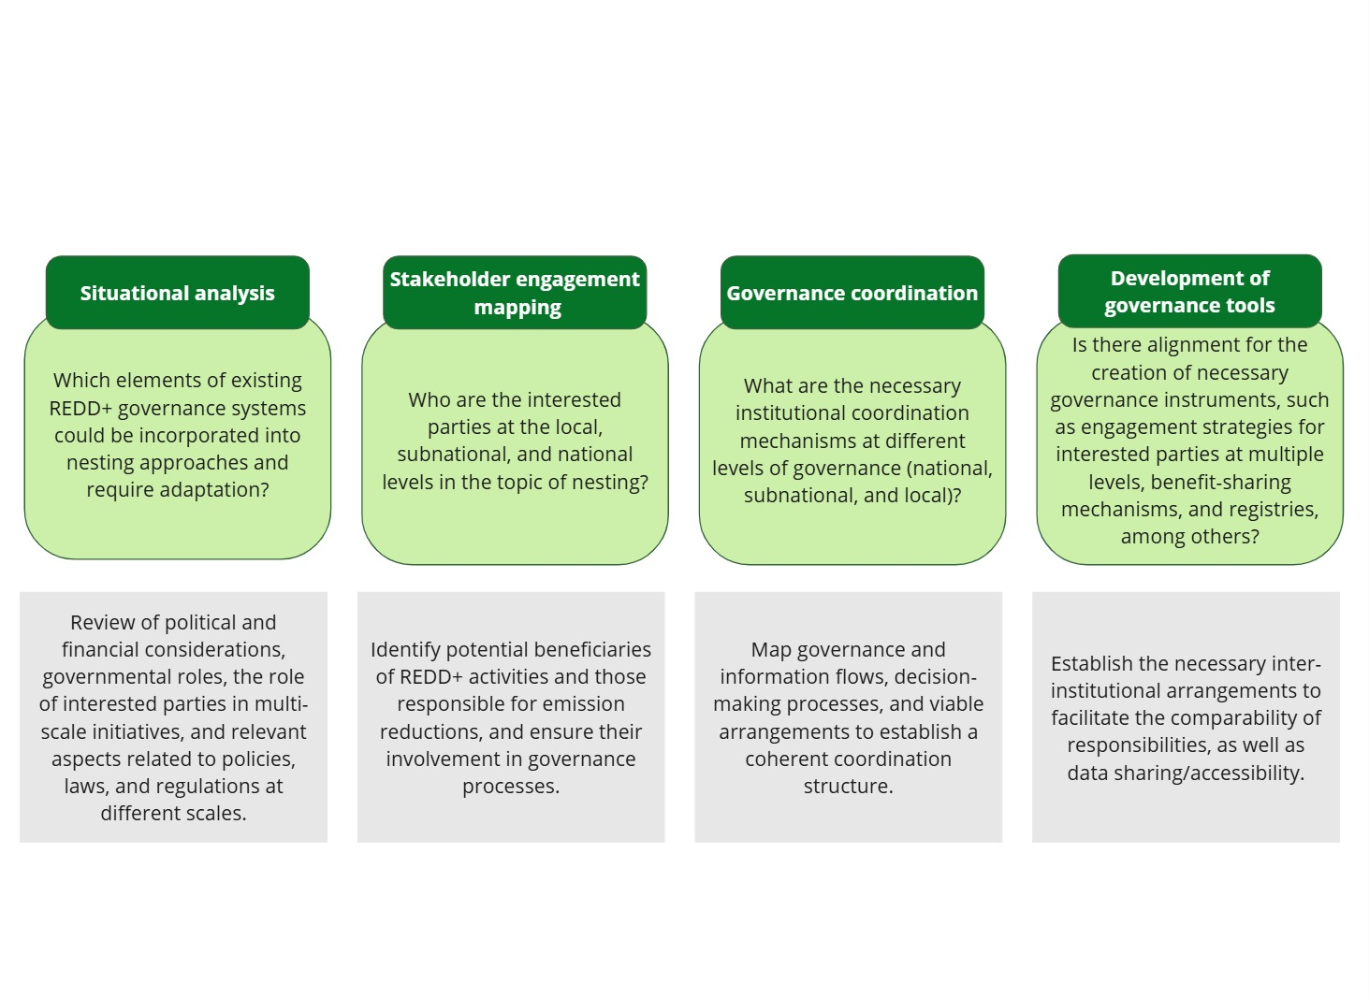

Figure 10 - Step-by-step process to foster debate on the nesting governance structure.

With respect to the existing governance framework, the Pará Jurisdictional REDD+ System is led by the state government, with SEMAS serving as the main agency responsible for its development. As such, SEMAS coordinates the formulation of climate policies and manages technical partnerships with different social groups to ensure that the system supports the state’s climate goals in alignment with national targets.

The state’s climate governance includes the following governance bodies:

* **Pará Forum on Climate Change and Adaptation (FPMAC):** a space for public agencies, entities, and civil society to discuss mitigation and adaptation to climate change in the state of Pará. Its objective is to promote cooperation and dialogue among different sectors of society to address climate-related issues, adaptation, and their socio-environmental and economic consequences. It includes two technical chambers: the Technical Chamber on Equity, Gender Equality, and Climate Change and the Technical Chamber on Youth.
* **Steering Committee of the State System on Climate Change (COGES):** composed of public authorities, NGOs, Indigenous peoples, quilombolas, and traditional communities, research institutions, and the productive sector. Its purpose is to analyse and deliberate on climate-related projects and studies and to exercise advisory, normative, and decision-making functions regarding the instruments of the Pará State Climate Policy.

Although these bodies have played an important role in the construction of the Jurisdictional REDD+ System, it is important to note that there is still no dedicated governance structure specifically for nesting. However, with SEMAS designated as the system’s coordinator, the responsibility for organizing efforts related to nesting will fall under its mandate, even though tasks may be distributed among different agencies responsible for related areas.

Several audiences must be engaged and topics addressed. From the perspective of harmonization with the federal government, SEMAS participates in working groups focused on jurisdictional system implementation and nesting strategies. Regionally, Pará leads the Interstate Consortium for the Sustainable Development of the Legal Amazon, which discusses regional common issues, including the implementation of jurisdictional programs.

The state's regulatory efforts are currently focused on the development and approval of the Draft Bill for the Jurisdictional REDD+ System of Pará, which aims to establish the system, set guidelines for benefit-sharing, and implement safeguards and monitoring mechanisms. According to information shared by the state, this draft will undergo public consultation starting in May 2025, when the document is expected to be publicly released.

In preliminary conversations with SEMAS, there is not yet a specific coordinated strategy in place defining roles, responsibilities, and the specific tools to be implemented. The registration document submitted to ART TREES in December 2024 refers to the development of a registry system aligned with best practices and federal regulations (including SBCE), intended to identify, account for, and publicly disclose all information related to emission reductions to avoid double counting of credits. Initial interactions suggest that this system will be developed at a later stage, potentially in the second half of 2025.

These questions emerged throughout the ALMA Brasil discussions, particularly as debates advanced on criteria related to accounting and MRV, safeguards, and land tenure. Questions included: where should a project developer submit a nesting request? Who will receive the submitted information, and how will it be stored, evaluated, and validated? Are there existing systems within SEMAS or other state agencies capable of pre-screening projects to streamline the information verification process? Based on these discussions, SEMAS acknowledged the need to organize the main demands on this front to be addressed in upcoming phases of the system.

To support this process, initial diagrams were prepared to promote debate on these needs, divided into specific steps: i. initial interaction between the project proponent and the state (**Figure 11**); ii. project registration with the state system **(Figure 12);** iii. project analysis within the jurisdictional system (**Figure 13**); iv. completion of nesting and engagement with the federal government (**Figure 14**).

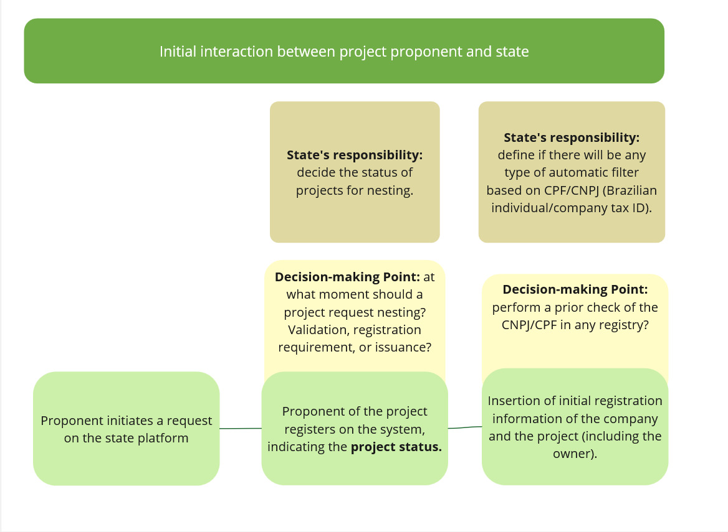

Figure 11 - Diagram for discussion – initial interaction between the project proponent and the state.

Figure 12 - Diagram for discussion – registration of the project proponent with the state system.

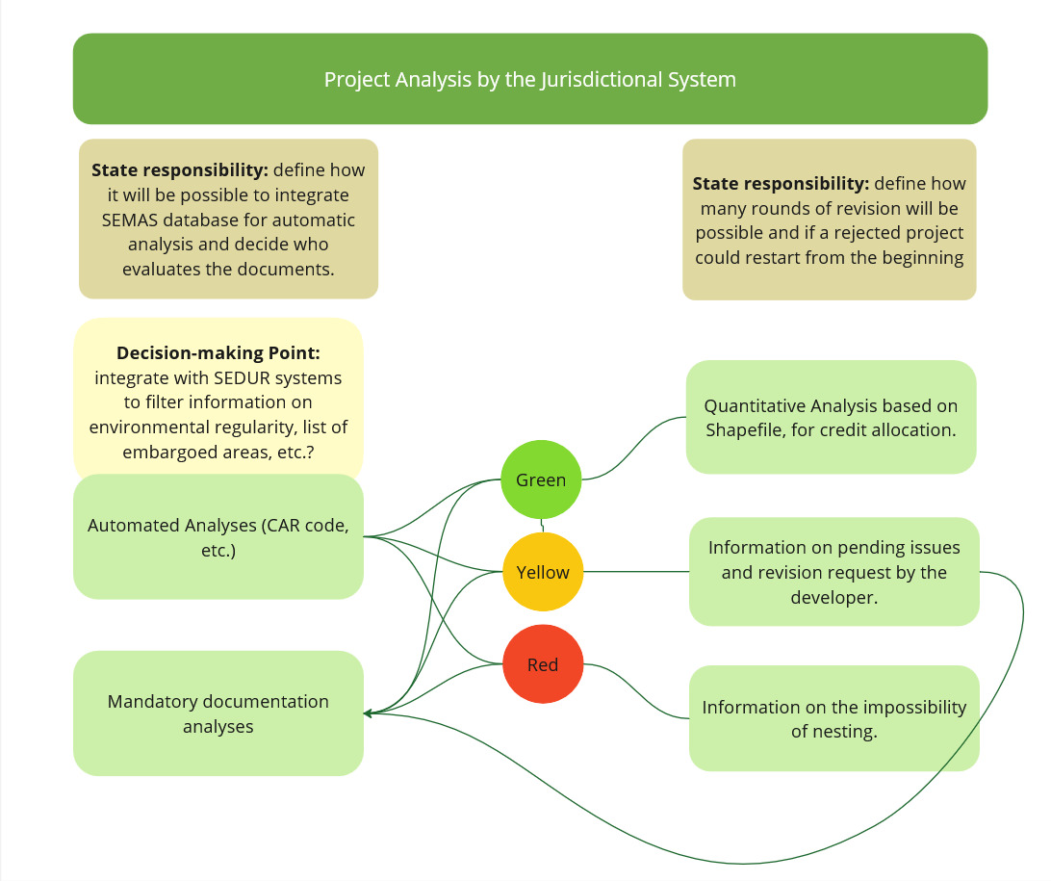

Figure 13 - Diagram for discussion – analysis of the project within the jurisdictional system.

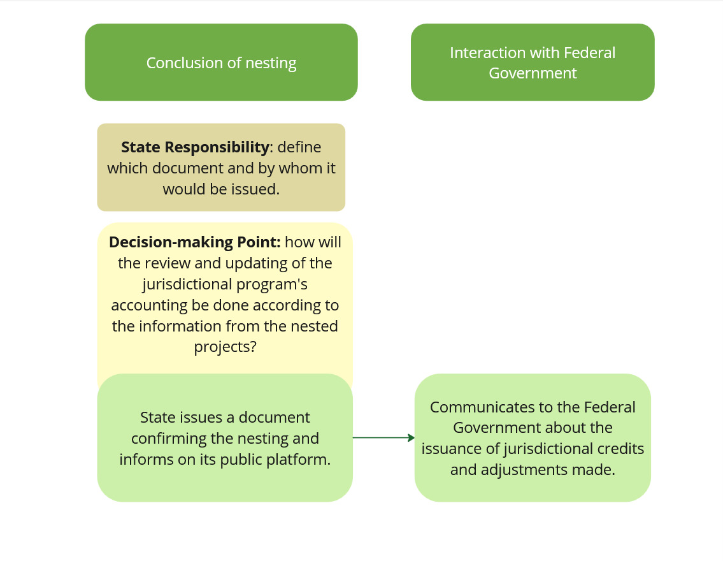

Figure 14 - Diagram for discussion – conclusion of nesting and engagement with the federal government.

The proposed structure aimed to spark discussions and highlight key points to be considered when designing a nesting system for the state. Among the main issues discussed:

* The state could either build its own platform and promote it through official channels for developers to submit projects or, through prior agreements with independent standards, integrate its system with platforms of standards operating in the state, such as Verra and Cercarbono. This would allow the state to identify all projects within its territory via the state platform, and later list them for nesting if desired. This way, the state would already have preliminary access to project information.
* The nesting system could be integrated into existing systems within state structures. Within SEMAS, for instance, the Selo Verde program could return relevant information about a property (e.g., environmental compliance, mapping, etc.) using the CAR code. Platforms beyond SEMAS could also be involved, such as accessing ITERPA's database for land tenure verification.
* Regarding the analyses to be conducted on the platform—across accounting, safeguards, and land tenure—once the criteria for each topic are defined, it is necessary to determine who within the system’s governance structure will be responsible, applicable deadlines, fees for analysis, distribution of collected fees, among other factors. The presented diagrams outline project assessments using a traffic-light system, as discussed in the specific sections. However, it’s worth noting that applying such a system is still in early stages of discussion. For example, recent discussions with ITERPA suggest a preference for not using a tiered approach, but rather a unified checklist based on property type.

Given the level of resources and effort likely required to carry out all steps and processes, there were discussions about potentially accrediting voluntary market standards and corresponding methodologies to simplify assessments (as mentioned in the safeguards section). This idea was also presented during pilot testing with developers, who responded positively to the possibility of process simplification. However, a key takeaway from the testing phase was the strong indication that formal state approval and a recognition document for the project are critically important to bolster investor confidence and strengthen the robustness of the overall system.

Therefore, governance discussions around nesting—and all the necessary procedures for its establishment, as well as related regulatory instruments and institutional arrangements—remain one of the main areas for further development in the next phase of the project.

### 4.3.3. Initial discussions and proposals

Given that the topic of operational procedures remains at an early stage of discussion and development, the proposals presented here are intended to outline ways to advance these themes throughout the upcoming phases of structuring and implementing the Pará Jurisdictional REDD+ System and its corresponding nesting strategy. In this regard, the key considerations are:

* It is necessary to gain a detailed internal understanding of the existing structures available to support the governance and operation of the system, as well as how current resources can be integrated into a dedicated platform.
* It is advisable to organize future engagements with the certification standards operating within the territory during the next phases of the nesting system’s development, with the aim of exploring possibilities for information integration and process automation.
* It is important to seek alignment with the national strategy prior to establishing a state-level registry system, to ensure compliance and harmonization across scales, while enabling future connection of accounting and transparency mechanisms.

1. **Progress, Key Considerations, and Next Steps**

Phase III of the ALMA Brasil project marked significant progress in the discussion around creating a safer and more robust environment for the voluntary carbon market, especially regarding Nature-Based Solutions (NBS) and the importance of attracting investment to priority regions such as the Brazilian Amazon.

The development of effective financing mechanisms for actions to combat deforestation—ensuring the participation and respect for Indigenous Peoples and traditional communities—is fundamental not only to the global climate agenda but, even more critically, to Brazil’s. This is justified by the fact that land-use change and agriculture account for approximately 70% of national GHG emissions.

In this phase, the focus on the state of Pará and on structuring its nesting strategy within the Jurisdictional REDD+ System was particularly relevant. The initiative made it possible to address various barriers already identified in the project's first phase, such as:

* The need for better coordination among political actors;
* Encouraging collaboration between public and private sectors on technical aspects of carbon markets;
* The diversity of methodologies and interpretations applied to REDD+;
* The urgency of harmonizing the regulatory environment to ensure transparency, functionality, and interoperability.

The active participation of the Pará state government was essential in identifying key challenges and contributing to the construction of solutions, taking into account insights gathered from different stakeholders throughout the process. Despite the high level of involvement, engaging multiple parties—each with distinct timelines and priorities—required flexibility in implementing activities, to respect the pace and concerns of all participants.

By the end of Phase III, substantial progress had been made in discussions on how the state can develop an efficient nesting system for projects within its still-developing Jurisdictional REDD+ System. This progress includes reflection on:

* Compatible methodologies and minimum criteria for projects seeking to nest within the state system.
* Existing and needed legal frameworks to support clear guidelines.
* Integration with federal policies and alignment with global carbon markets.
* Risks and necessary safeguards to avoid compromising the viability of programs and projects.
* Engagement with project developers was productive, although real-world pilot testing was limited by two factors: the delay in defining analysis criteria and the need to build trust-based relationships for the exchange of sensitive information.

Nonetheless, Phase III concludes on a positive note, with tangible expectations for continued collaboration—especially for refining and validating the initially considered and proposed criteria**. Table 12, Table 13** and **Table 14** summarize the landscape and main outcomes achieved in this stage, and also highlight outstanding topics to be addressed in upcoming phases.

Table 12 - Considerations on Accounting and MRV.

Table 13 - Considerations on Safeguards and Land Regulation.

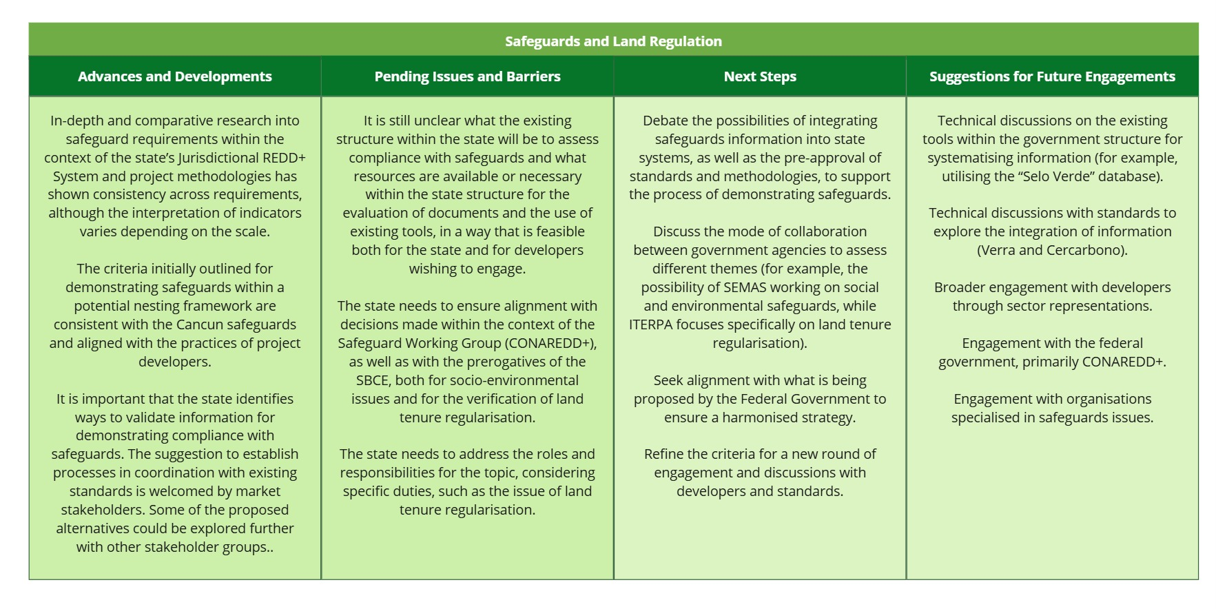

Table 14 - Considerations on Operational Procedures.

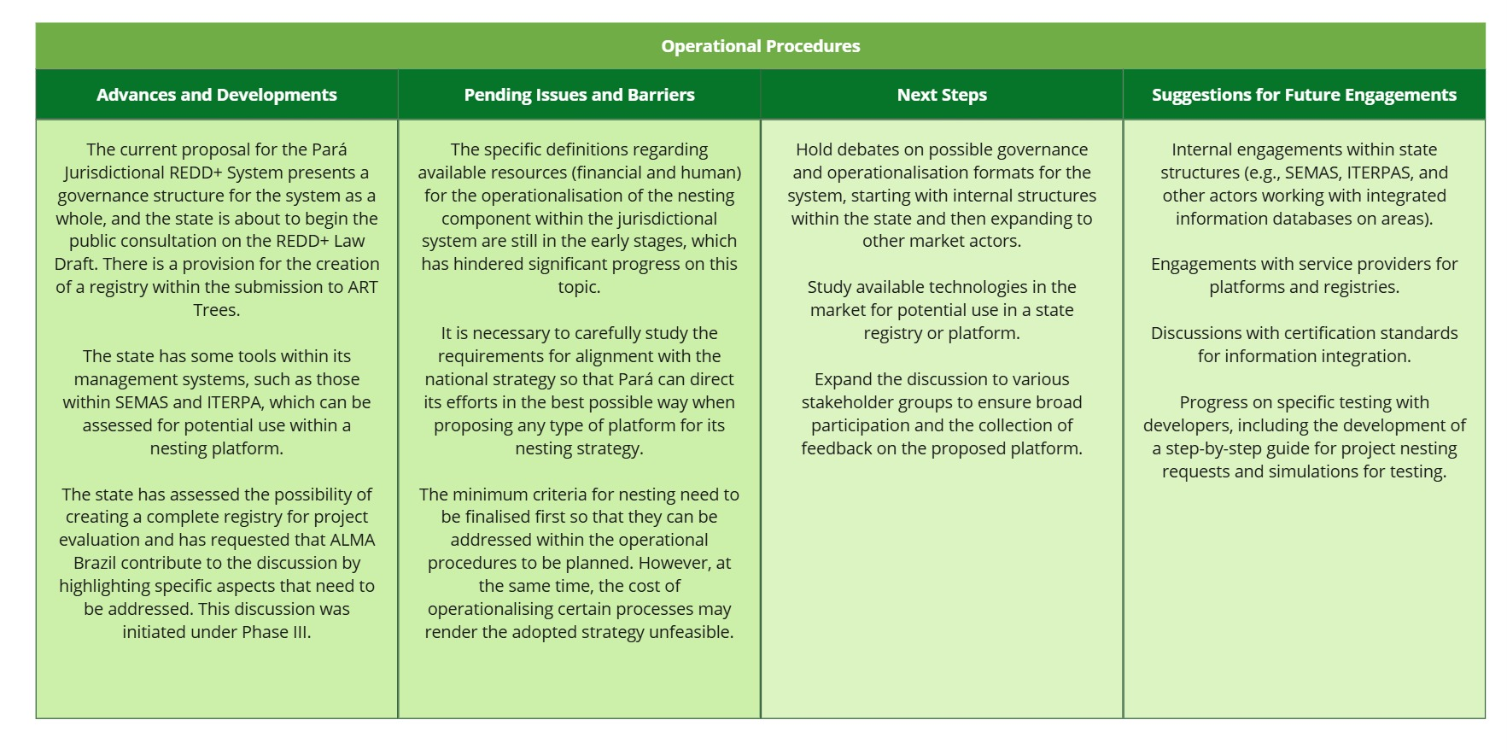

The structuring of Pará’s Jurisdictional REDD+ System is taking place at a particularly critical time for the market, which is seeking to strengthen integrity strategies and ensure the interoperability of different mechanisms—understanding that this is one of the main ways to direct resources toward priority areas.

It is important to emphasize that, above many other issues, it is essential to develop a harmonized accounting system that aligns with both the Federal Government and the broader market—something that goes beyond the nesting strategy itself.

In a landmark year for Brazil, as the country prepares to host COP30—in the state of Pará itself—moving this debate forward efficiently and with the integration of the various impacted stakeholders is vital to providing strong examples and references that could also be discussed with other jurisdictions.

1. **Closing remarks**

The report presented here aimed to outline the progress made during Phase III of the ALMA Brasil project. It is important to highlight the changes in relation to what was initially planned (see Section 3) in the Phase II deliverable — the Implementation Plan. In addition to the fact that the testing phase was only initiated, due to the previously explained barriers, the dissemination of results will also need to be developed in the eventual next phases, when it is expected that information on the criteria for a nesting strategy in Pará will be more mature and better discussed with the various impacted and engaged stakeholders.

It is reiterated that this report is an interactive document which, should the project move forward, will continue to be refined with input from the Advisory Board and other involved stakeholders, helping to support future discussions and facilitating engagement and actions in the next stages

1. **Annexes**

## Annex 1 – Examples of Evaluation Using Traffic Light Systems – Socioenvironmental Safeguards

Table 15 - Suggested categories of information assessed for compliance with safeguards related to adherence to current environmental legislation.

| **Aspect Analyzed** | **GREEN – Ideal Documents** | **YELLOW – Points for Analysis** | **RED – Insufficient Documents** |
| --- | --- | --- | --- |
| CAR Status | Active | Pending | Canceled |
| CAR Condition | Analyzed with no pending issues | Analyzed with pending issues, awaiting rectification and/or submission of documents | Not analyzed |
| Environmental balance | No deforestation post-2008 | No deforestation post-2008, but with APP or RL deficit, with ongoing adjustment terms | Deforestation post-2008, with APP or RL deficit and no ongoing adjustment terms |
| Socioenvironmental inspection | Absence of: Infraction Notice, Environmental Embargo, Environmental Release, Forced Labor, Processes in SIFLOR  Existence (if applicable) of: Environmental License, Vegetation Suppression Authorization, Rural Activity License | Existence of Infraction Notice, Environmental Embargo, Environmental Release, in regularization process  Environmental documents required, in regularization process: Environmental License, Vegetation Suppression Authorization, Rural Activity License | Existence of Infraction Notice, Environmental Embargo, Environmental Release, with no regularization process  Forced Labor Notification  Environmental documents required not identified: Environmental License, Vegetation Suppression Authorization, Rural Activity License |
| CAR Overlap with Rural Settlements, Indigenous Lands, Conservation Units, Quilombola Territory, or Public Forests Not Designated | No overlap | Overlap – in regularization process | Overlap – no regularization process |

## Annex 2 – Examples of Evaluation Using Traffic Light Systems – Land Tenure Safeguards

Table 16 - Initial list of documents to be requested for projects regarding land tenure regularity demonstration.

| **Aspect Analyzed** | **GREEN – Ideal Documents** | **YELLOW – Points for Analysis** | **RED – Insufficient Documents** |
| --- | --- | --- | --- |
| Private Property/Owners | Set of required documents:  a. Property Registration Certificate (CRI) - Full certificate of the ownership chain showing the separation of the area from public land.  b. Authenticity certificate of the title issued by ITERPA for state areas and by INCRA for federal areas.  Observation: Updated project registration certificate,[21] issued at least 30 days before submission, can be presented but will only be validated upon presenting items (a) and (b). | Documents subject to evaluation:  a. Property title.  b. Updated property registration certificate[22], issued at least 30 days before submission. The registration must indicate the person in question as the property owner.  c. Authenticity certificate of the title issued by ITERPA for state areas and by INCRA for federal areas.  Observation: Any document that does not indicate the separation of the area from public land should undergo further analysis. | Self-declaratory documents, such as:  a. SIGEF with INCRA  b. Self-declaration of ownership: a self-declaration is not sufficient to attest to ownership/possession.  c. Descriptive memorial/CAR/CCIR/ITR documents/receipts: these are accessory documents (tax, cadastral, etc.) that do not regulate ownership/possession.  Observation: This type of documentation is insufficient to attest to ownership/possession. The accessory use of CAR, however, can help demonstrate that there are no disputes between neighboring properties by analyzing the cadastral data of the property in question and the adjacent ones. |
| Land Reform Settlements – CCU, CDRU, TD, Property Title – ITERPA or INCRA | Set of required documents:  a. Title of Use Concession or Use Concession Contract - Copy of the property titling document (e.g., CCU, CDRU, TD, Property Title) issued in favor of the person in question.  b. Proof of payment of the acquisition price (for onerous contracts) and proof of compliance with resolutive conditions and other obligations (Art. 33 of INCRA’s IN 99/2019 and Pará State Decree No. 1,190 of 11/25/2020, as applicable). | Cases for additional analysis:  a. Absence of proof of payment of the acquisition price (for onerous contracts) and proof of compliance with resolutive conditions and other obligations: This matter can be integrated with the respective INCRA Regional Superintendency for confirmation.  b. INCRA certificate and/or Beneficiaries List: Although it indicates that the farmer is settled under a certain project and has been assigned a plot, it does not confirm the resolutive conditions of the title. This matter can be integrated with the respective INCRA Regional Superintendency for confirmation.  c. INCRA occupation authorization: The authorization only allows precarious and temporary possession of the property; once the conditions are fulfilled, INCRA should have granted a definitive title to the farmer. This matter can be integrated with the respective INCRA Regional Superintendency for confirmation. | Justifications for exclusion:  a. INCRA certificate indicating the existence of a settlement process/copy of the registration in the settlement process: these are not sufficient documents to attest ownership/possession, as the existence of the process/registration does not demonstrate its outcome.  b. Documents in the name of family unit members, as indicated by the respective record: It will be important to verify at least the participation or consent of the titleholder in the project, declaration, or other legal link that is intended to be established or, ideally, of all family[23] unit members, to ensure compatibility with the intended land use activities. |
| Conservation Unit | National Register of Conservation Units – CNUC. Observation: One discussion point concerns requesting the completed Management Plan. However, based on examples, it was raised that many conservation units have faced difficulties in finalizing their plans, which could hinder the entry of these types of projects. Further discussion may be needed regarding which other bodies to involve (e.g., IDEFLOR) and to assess if REDD+ projects are included in state concession calls. | - | - |
| Quilombola territory | Self-Definition Certificate. Collective Property Title. | Ongoing land regularization process with INCRA and ITERPA.  Observation: If a title has not been granted, the state could evaluate the project's relevance in the territory and understand the nuances regarding original rights. | No collective property title or ongoing regularization process. |
| Indigenous land | FUNAI’s Consent. Indigenous Land Declaration Ordinance. Physical Demarcation.  Observation: In the case of indigenous land, there is a discussion about leaving the responsibility to FUNAI. In this case, the state would not perform any analysis and would rely exclusively on FUNAI's consent to anchor the project. To be discussed. | - | - |
| Possessor - Instrument with Third Property Owner (e.g., Loan Agreement, Lease Agreement, Rights Transfer, Donation Deed, Sale Deed, Surface Rights Deed) | a. Updated property registration certificate, issued at least 30 days before submission. The registration must show the grantor of the contract as the owner.  b. Copy of the property titling document (e.g., CCU, CDRU, TD, Property Title) issued in favor of the owner. [For land regularization cases – as applicable]. Verify conditions of permanence - obligations outlined in Art. 15 of Federal Decree No. 9,311/2018 or Art. 53 of Pará State Decree No. 1,190 of 11/25/2020 (as applicable), and others that may be specified in the document and must be complied with, as they have a resolutive condition nature.  c. Proof of payment of the acquisition price (for onerous contracts) and proof of compliance with the resolutive conditions and other obligations. [For land regularization cases – as applicable]. The owner must have fully paid the acquisition price and complied with the resolutive conditions and other obligations outlined in the title (Art. 33 of INCRA’s IN 99/2019 and Pará State Decree No. 1,190 of 11/25/2020, as applicable).  d. Copy of the instrument regulating the farmer's possession of the property (e.g., Loan Agreement, Lease Agreement, Rights Transfer, Land Exchange Agreement, Donation Deed, Sale Deed, Surface Rights Deed). | Land exchange contract / donation declaration / titles from land exchange and donation, respectively. If not registered in the property registration, subject to evaluation based on the other documents listed in the adjacent column.  Declaration of possession in favor of the farmer issued by a third party: certificate of full content of the registration in the third party's name required. Absence of proof of payment of the acquisition price (for onerous contracts) and proof of compliance with resolutive conditions and other obligations: This matter can be integrated with the respective INCRA Regional Superintendency for confirmation.  There may be legal actions questioning the ownership and/or possession of the property, as applicable, and relevant liens and encumbrances that may interfere with the owner’s rights. | Self-declaration of occupation/possession: a self-declaration is not sufficient to attest to ownership/possession. Descriptive memorial/CAR/CCIR/ITR documents/receipts: these are accessory documents (tax, cadastral, etc.) that do not regulate ownership/possession. Therefore, they are insufficient to attest to ownership/possession. Instruments that regulate real rights (sale, exchange, surface rights, etc., as per Art. 1,225 of the Civil Code) must have a specific form: if the property, at the time of the instrument, was worth more than thirty times the highest minimum wage in the country, the instrument must be presented in public deed form. According to Art. 108 of the Civil Code, private instruments would not be valid in this situation. |

Endnotes

1. The Phase I report is available [here.](https://ietaicroa.sharepoint.com/:b:/s/IETA/EQphTL78sw5IjSkQWORvEUEBPhVGtk7k_fS48mKrOp5jhQ)
2. The implementation plan (Phase II) is available [here.](https://ietaicroa.sharepoint.com/:b:/s/IETA/EWo8LuIPMXpChkGbJaX-aqoBaUSW7ZYEZKpWF6bjHj_GzQ?e=musoAN)
3. Public information about Pará’s Jurisdictional REDD+ System can be found [here.](https://www.semas.pa.gov.br/redd/componentes-do-sistema-jurisdicional-de-redd-no-para/).
4. The initial forms shared with the selected developers can be accessed [here.](https://docs.google.com/forms/d/e/1FAIpQLSc_g-h7IQzyT2LobX5bw7WredBTQvLCD4LIvnZIEN9i9ONTAg/viewform?usp=header)
5. Wildlife Works was the third company to express interest in collaborating with the project. However, by the time the report was finalized, neither the completed forms nor the signed NDA had been submitted. Therefore, engagement will continue in future phases of the project, incorporating any contributions received in the subsequent stages.
6. Information contained in the registration document dated 31 December 2024 does not reflect changes made after this date.
7. Brazilian FREL, available [here.](https://redd.unfccc.int/submissions.html?country=bra)
8. PRODES, DETER and TerraClass constitute the official national information sources and are available on the websites of the National Institute for Space Research (INPE) and the platform [TerraBrasilis](http://www.inpe.br/cra/projetos_pesquisas/dados_terraclass).
9. [More information](https://www.ccst.inpe.br/projetos/eba-estimativa-de-biomassa-na-amazonia/) about Project EBA.
10. Pará's interpretation is that, regardless of the type of selective logging, deforestation accounting must occur, considering that biomass loss and the consequent emissions take place, even though geometric logging is more related to deforestation with greater planning.
11. [BeZero Ratings: A first look at VM0048: winners, losers, and the price to pay.](https://bezerocarbon.com/insights/a-first-look-at-vm0048-winners-losers-and-the-price-to-pay)
12. The timeline for publishing the risk maps is available [here](https://verra.org/methodologies-main/transition-process-for-aud-redd-projects/).
13. [Verra technical note](https://verra.org/methodologies-main/availability-of-allocated-deforestation-risk-maps/allocated-deforestation-risk-maps-data-technical-notes-brazil/) on the differences between the data used in the national FREL and why they cannot be used in the application of vm0048 and its modules.
14. Latest version of the VCS standard, available[here.](https://ietaicroa.sharepoint.com/sites/IETA/Documents%20partages/Working%20Groups/Special%20Initiatives/ALMA%20Brasil/3.%20News%20and%20Developments/Phase%20III/Phase%20III%20Report/Nesse%20sentido,%20embora%20programas%20ou%20padrões%20de%20certificação%20exijam%20o%20cumprimento%20de%20salvaguardas%20mínimas%20gerais%20para%20assegurar%20que%20projetos%20não%20gerem%20impactos%20negativos%20e%20tragam%20benefícios%20concretos%20para%20as%20partes%20interessadas%20envolvidas,%20o%20fato%20de%20alguns%20projetos%20não%20aplicarem%20as%20ações%20devidas%20e%20as%20complexas%20realidades%20fundiária%20e%20socioeconômica%20do%20Brasil%20demonstram%20a%20necessidade%20de%20instrumentos%20públicos%20que%20promovam%20a%20transparência%20e%20assegurem%20condições%20estruturais%20favoráveis%20à%20efetiva%20transformação%20socioeconômica%20nas%20regiões%20onde%20os%20projetos%20se%20desenvolvem%20de%20maneira%20respeitosa%20aos%20direitos%20de%20populações%20indígenas%20e%20comunidades%20tradicionais.).
15. Latest version of the CCB standard, available[here.](https://ietaicroa.sharepoint.com/sites/IETA/Documents%20partages/Working%20Groups/Special%20Initiatives/ALMA%20Brasil/3.%20News%20and%20Developments/Phase%20III/Phase%20III%20Report/Nesse%20sentido,%20embora%20programas%20ou%20padrões%20de%20certificação%20exijam%20o%20cumprimento%20de%20salvaguardas%20mínimas%20gerais%20para%20assegurar%20que%20projetos%20não%20gerem%20impactos%20negativos%20e%20tragam%20benefícios%20concretos%20para%20as%20partes%20interessadas%20envolvidas,%20o%20fato%20de%20alguns%20projetos%20não%20aplicarem%20as%20ações%20devidas%20e%20as%20complexas%20realidades%20fundiária%20e%20socioeconômica%20do%20Brasil%20demonstram%20a%20necessidade%20de%20instrumentos%20públicos%20que%20promovam%20a%20transparência%20e%20assegurem%20condições%20estruturais%20favoráveis%20à%20efetiva%20transformação%20socioeconômica%20nas%20regiões%20onde%20os%20projetos%20se%20desenvolvem%20de%20maneira%20respeitosa%20aos%20direitos%20de%20populações%20indígenas%20e%20comunidades%20tradicionais.)
16. Latest version of the Cercarbono standard, available [here.](https://www.cercarbono.com/wp-content/uploads/2024.10.02-Safeguarding-Principles-and-Procedures-of-Cercarbono-V2.0.pdf).
17. More information on the sustainable development tool of Article 6.4 can be found [here.](https://unfccc.int/sites/default/files/resource/A6.4-TOOL-AC-001.pdf))
18. News on the topic: <https://www.gov.br/pf/pt-br/assuntos/noticias/2024/06/pf-deflagra-operacao-greenwashing-para-investigar-venda-irregular-de-creditos-de-carbono> and <https://g1.globo.com/podcast/o-assunto/noticia/2023/10/03/fraude-na-amazonia-como-e-portel-cidade-onde-empresas-particulares-estao-usando-terras-publicas-para-emitir-creditos-de-carbono.ghtml>
19. Trench Rossi and Pinheiro Neto.
20. [REDD+ ACADEMY Learning Journal: Nesting Approaches for REDD+. 2024.](https://www.un-redd.org/sites/default/files/2025-02/REDD%2B_NESTING_journal%20_2024.pdf)
21. The current land registration system is the matrícula. However, some properties may still have transcriptions (a previously used document). In such cases, a certidão da transcrição (transcription certificate) must be presented. With the number of the matrícula/transcription and the competent Real Estate Registry Office, it is possible to issue a full content certificate—in most states, even online, through the.[ONR website](https://registradores.onr.org.br/CertidaoDigital/frmPedidosCertidao.aspx?from=menu&digital=1).
22. The current land registration system is the matrícula. However, some properties may still have transcriptions (a previously used document). In such cases, a certidão da transcrição (transcription certificate) must be presented. With the number of the matrícula/transcription and the competent Real Estate Registry Office, it is possible to issue a full content certificate—in most states, even online, through the.[ONR website](https://registradores.onr.org.br/CertidaoDigital/frmPedidosCertidao.aspx?from=menu&digital=1)
23. Article 3 of Decree 9.311/2018: “Family unit – a family composed of the titleholders and other members who jointly exploit or propose to exploit a portion of agrarian reform land, with the aim of meeting their own subsistence needs and the society’s demand for food or other goods and services.”